**(21) Cyclone**

1. AIR MASS , Cyclone

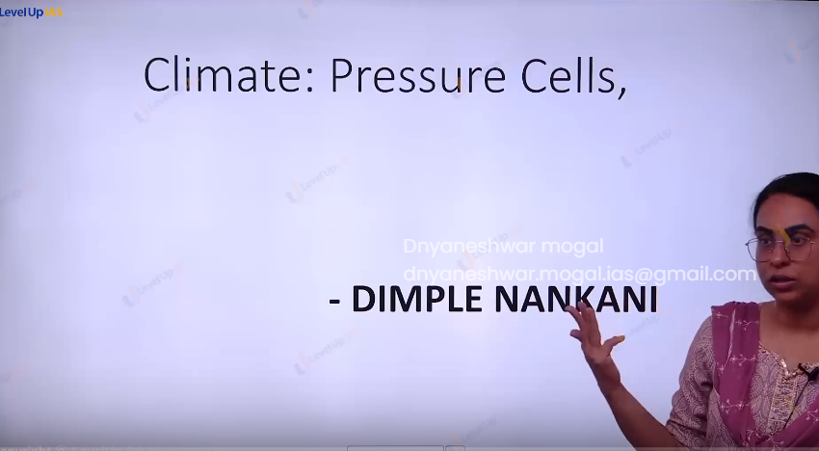

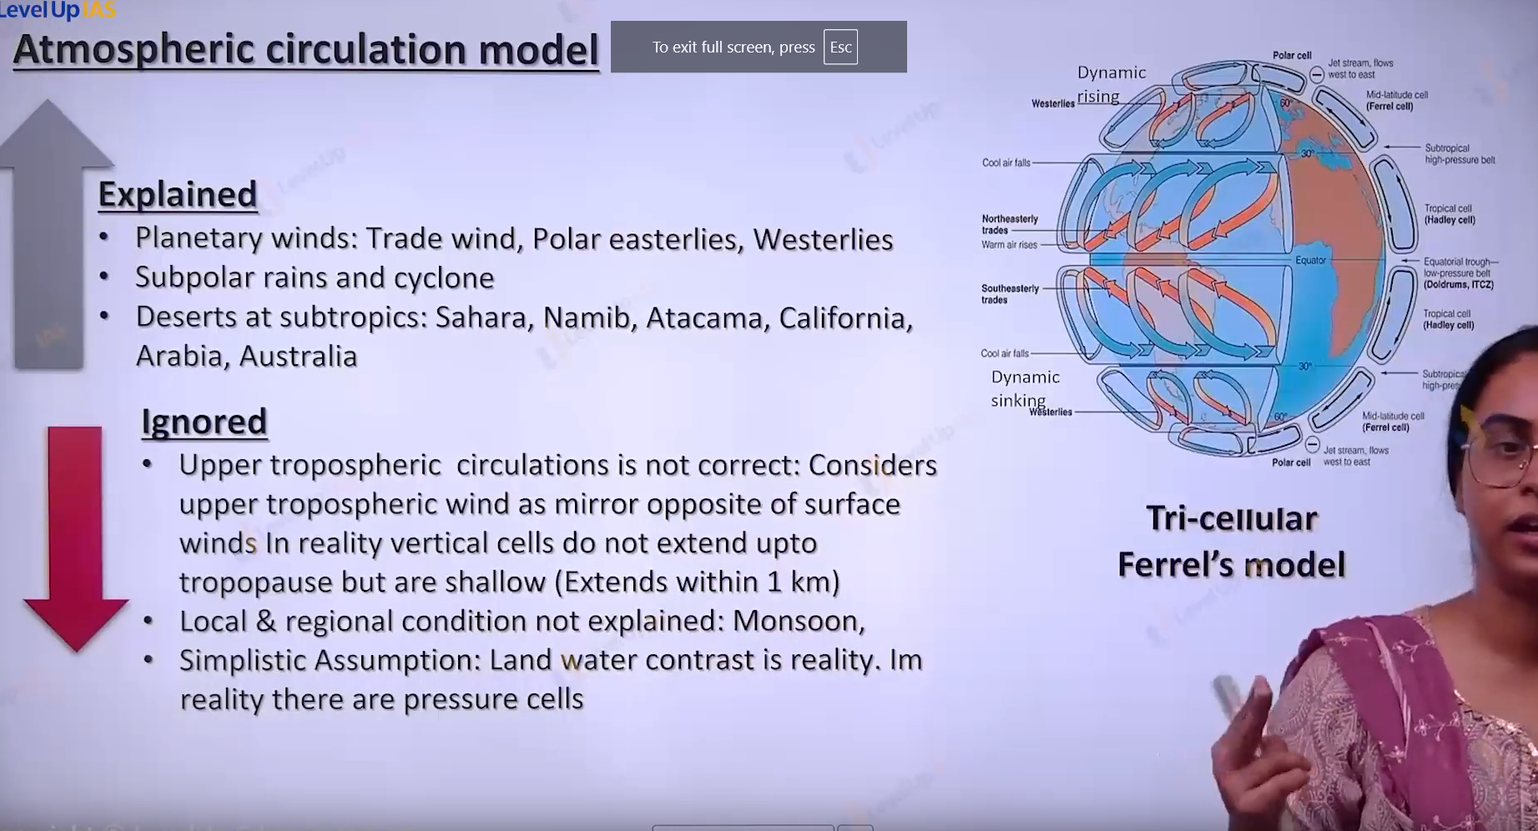

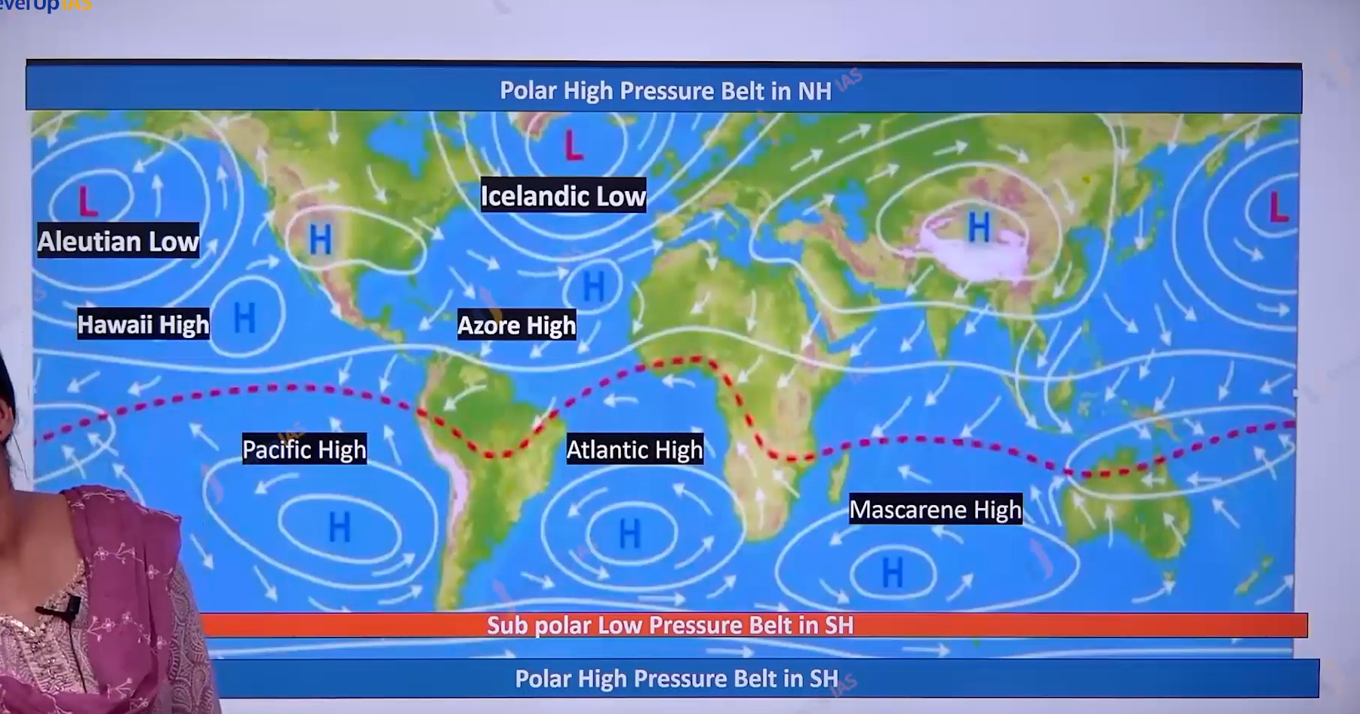

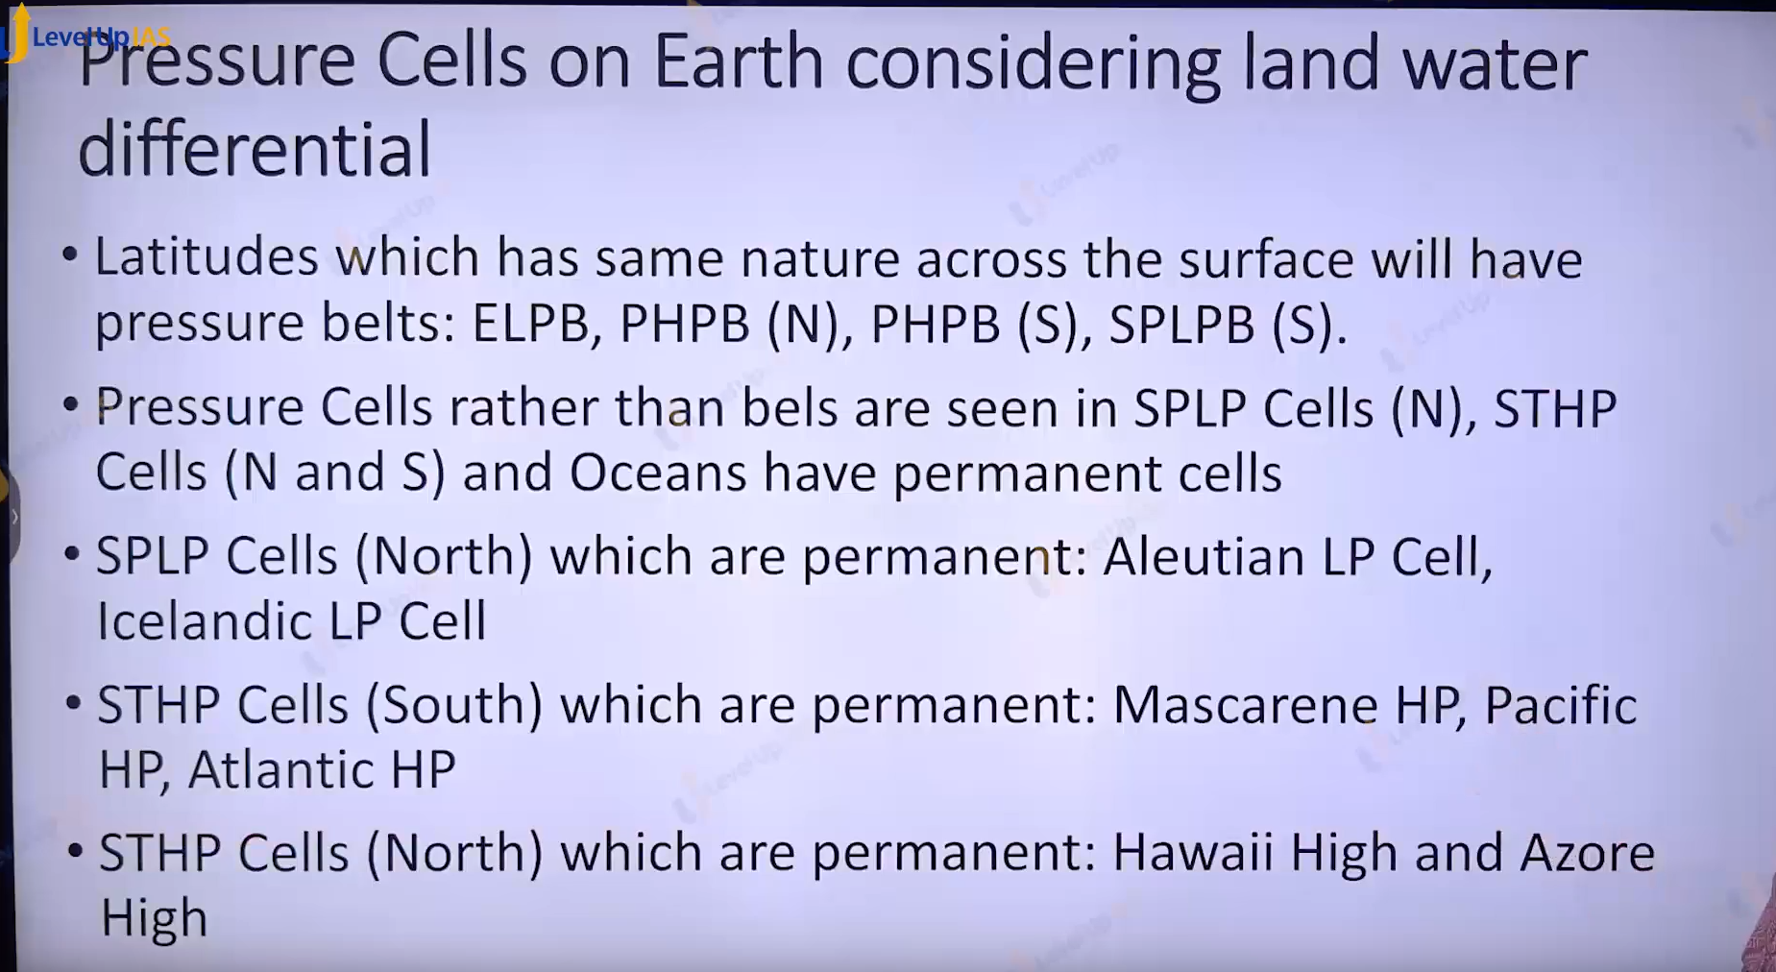

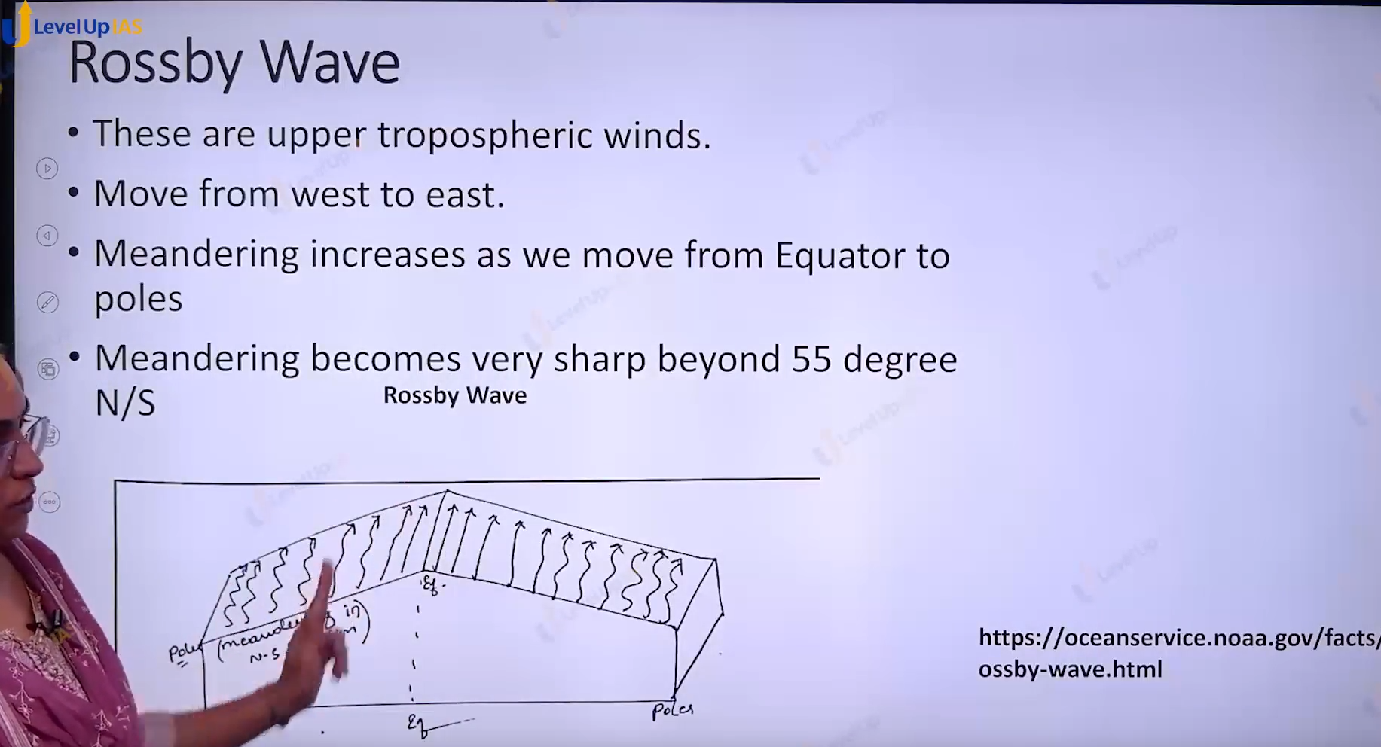

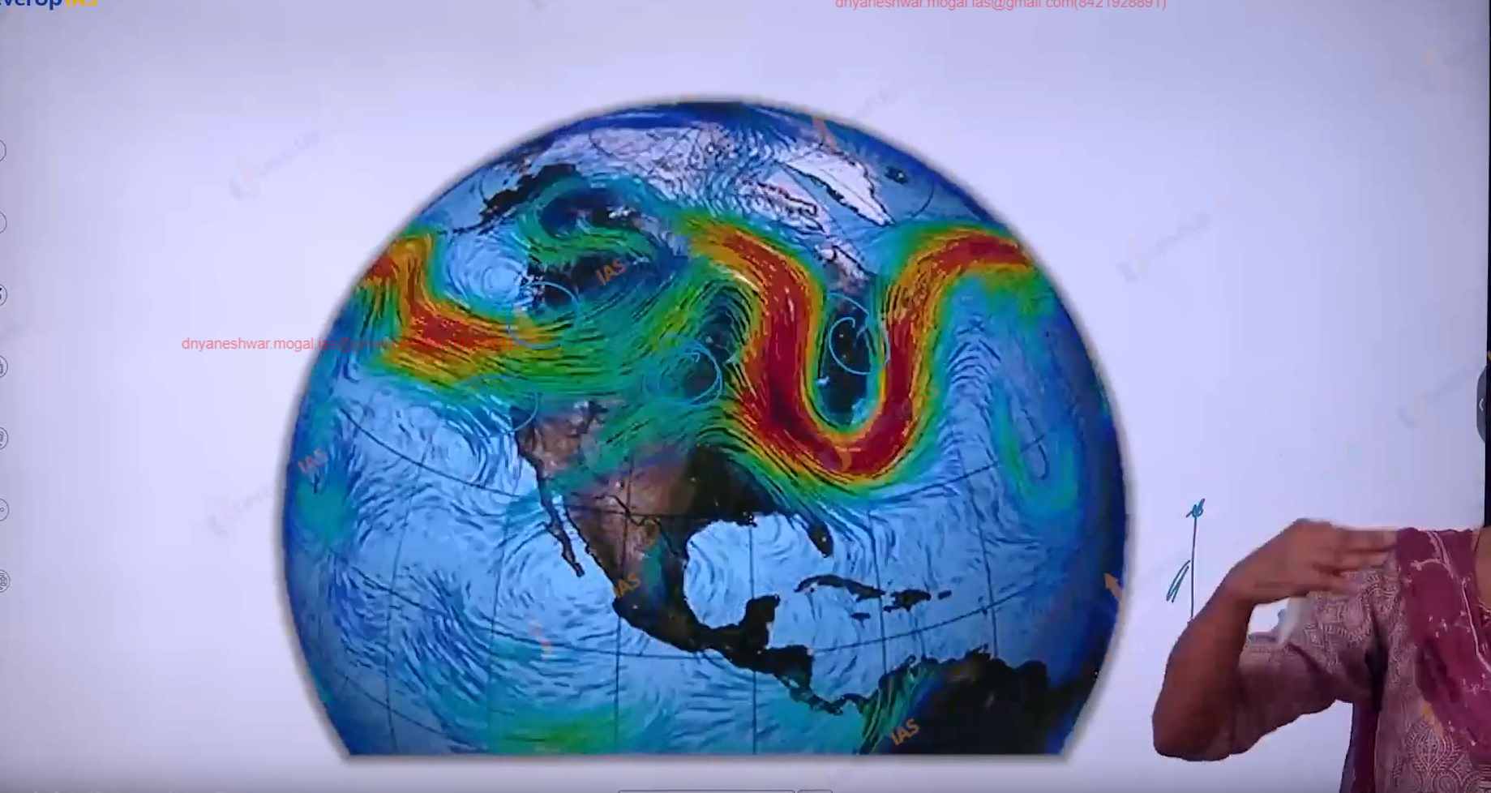

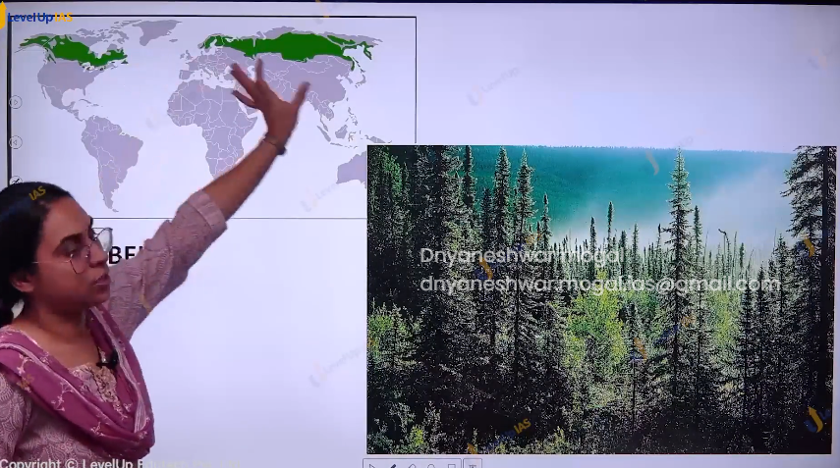



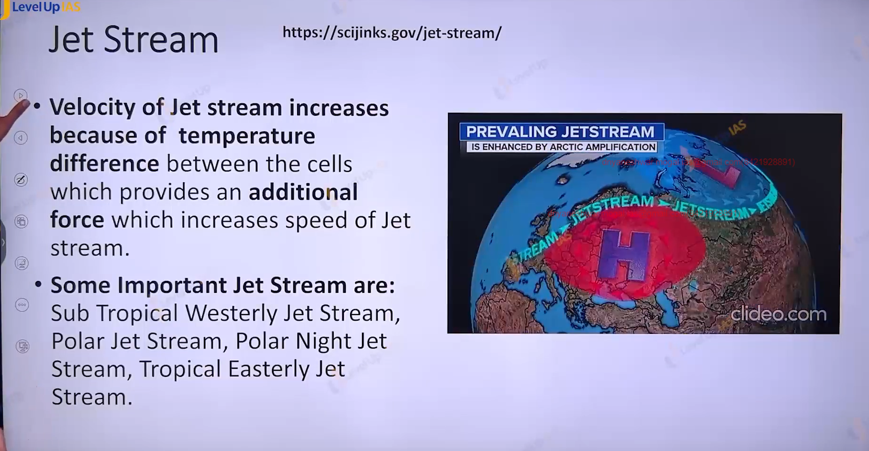

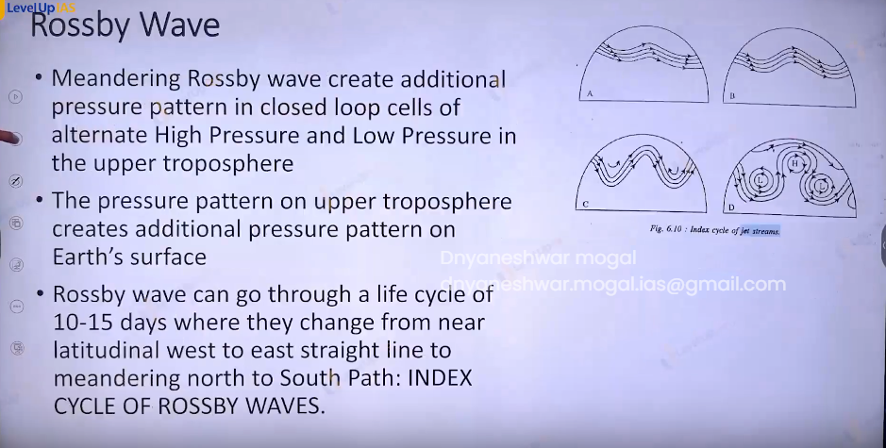

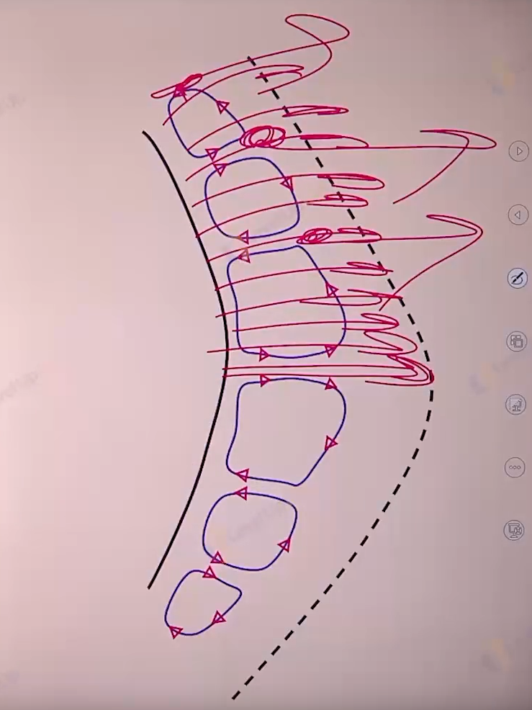

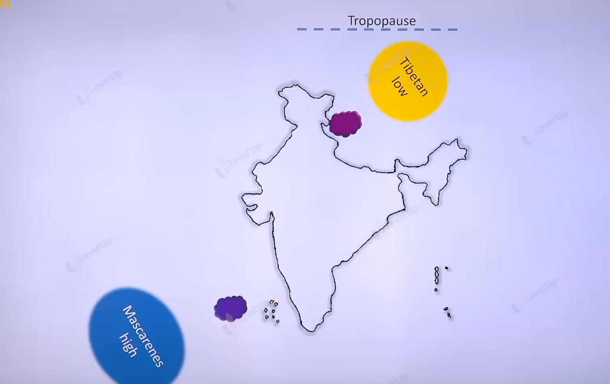

Cyclone: low pressure cell where the air circulates. There are 2 types of cyclones

1. Tropical cyclone: tropic 30 to 10 degree north and 30to 10 degree south
2. Temperate cyclone: temperate cyclone 35 to 55 degrees north and 35 to 55 degrees south.

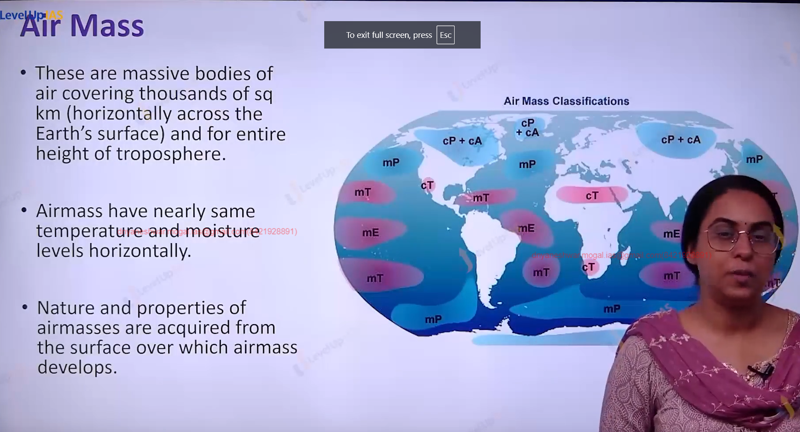

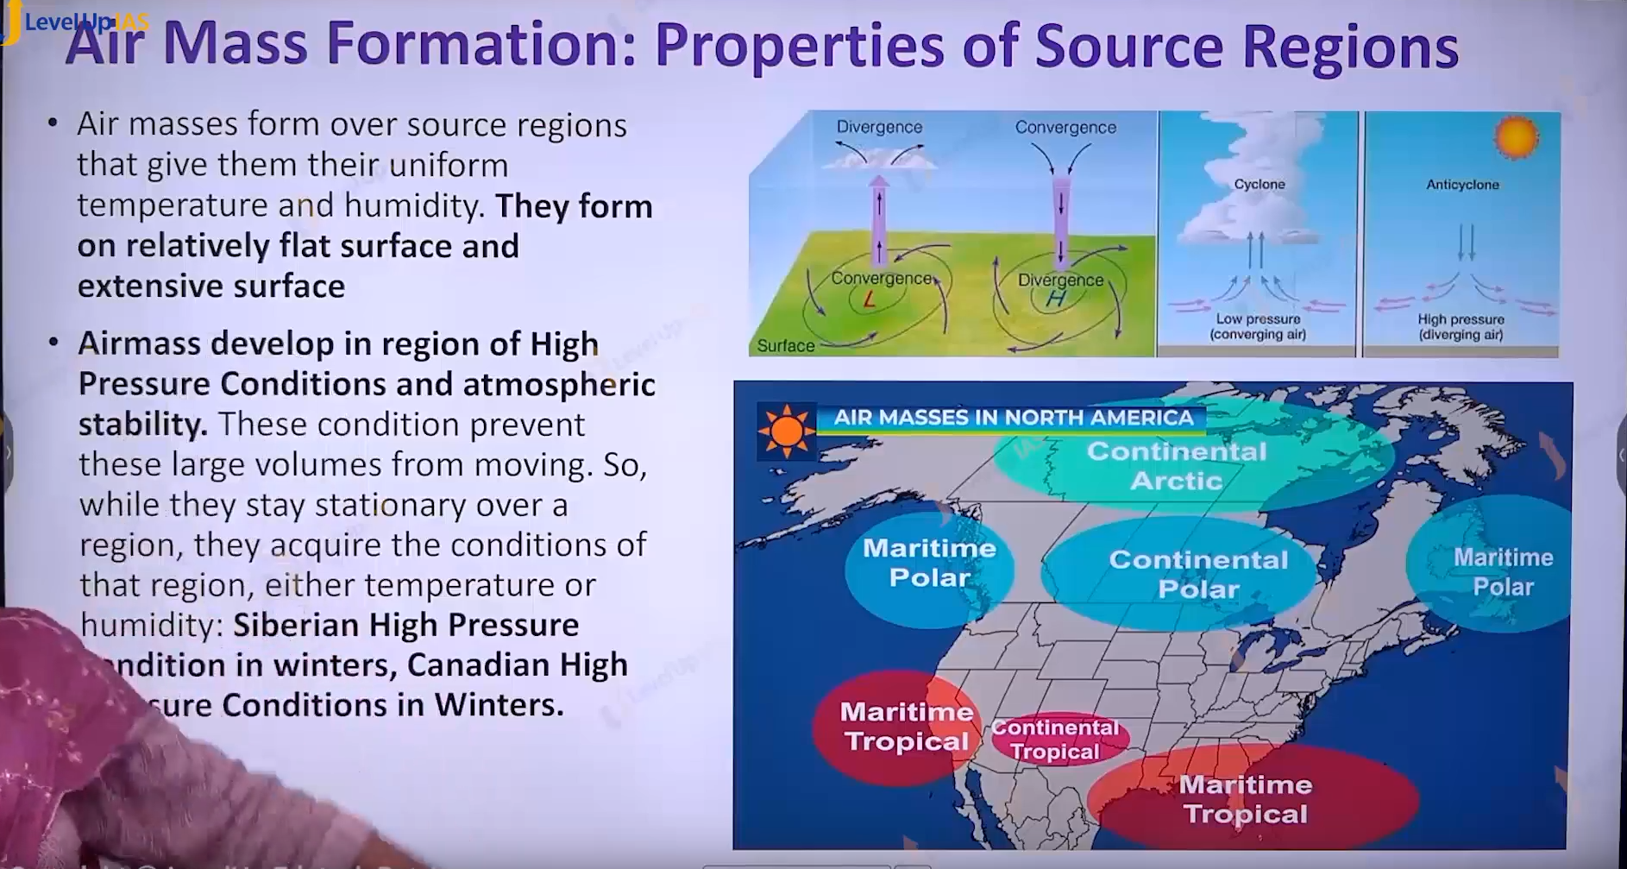

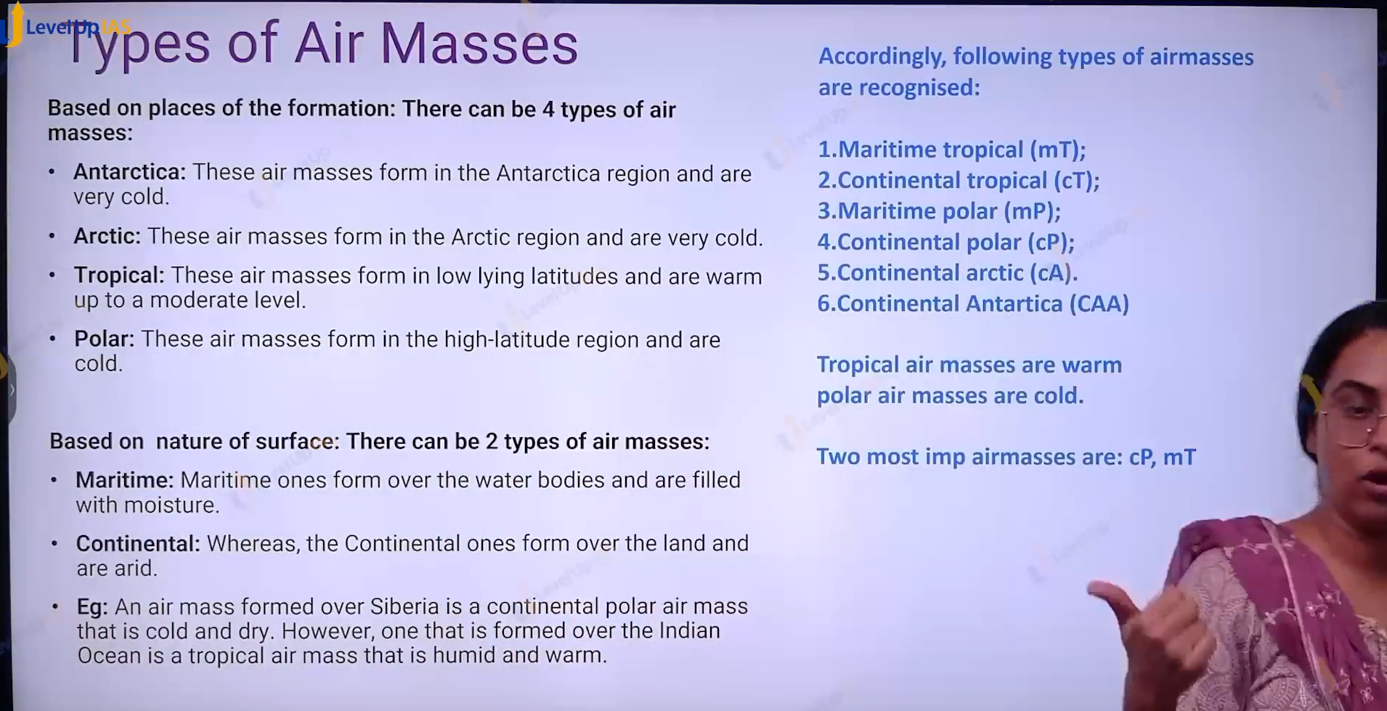

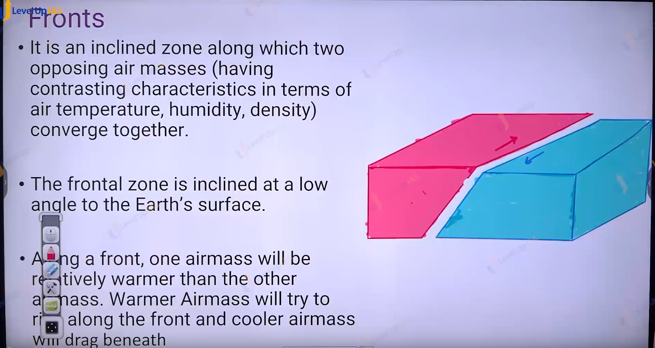

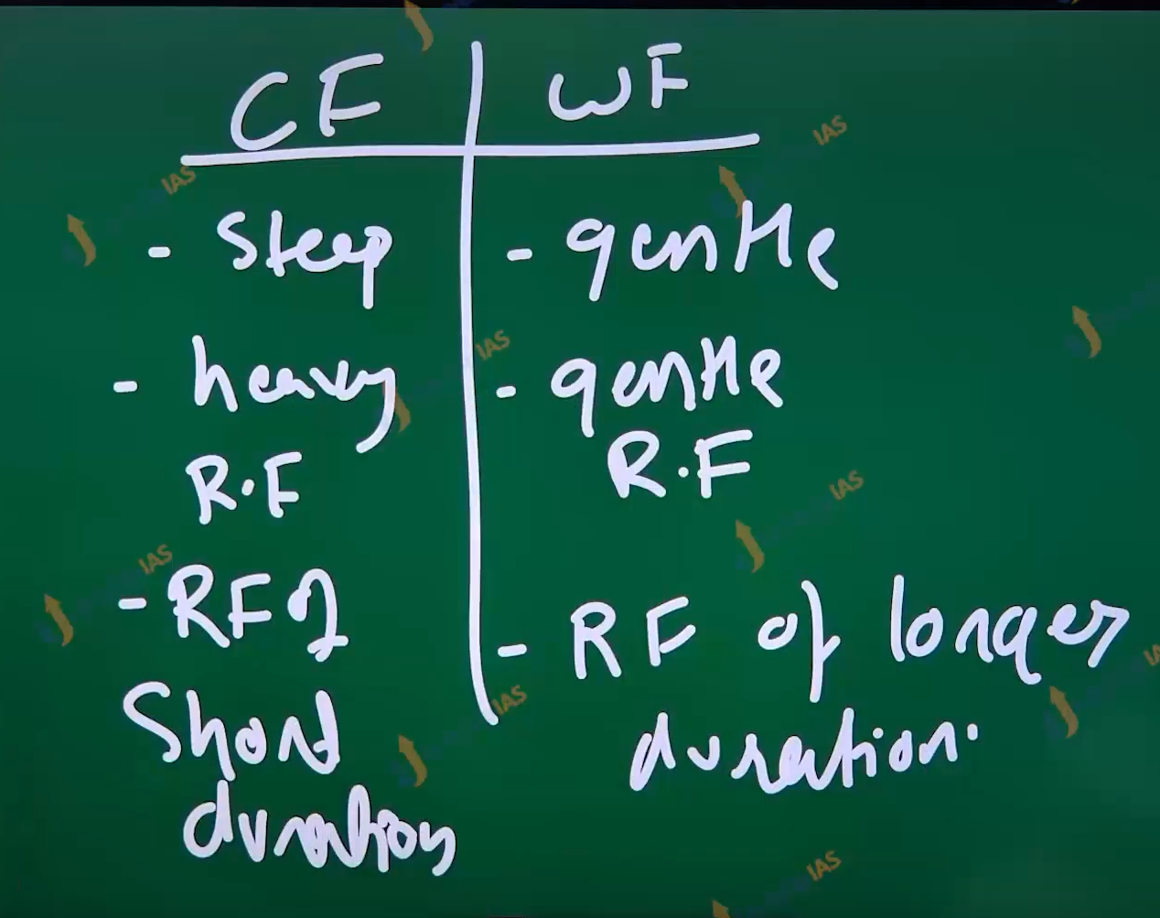

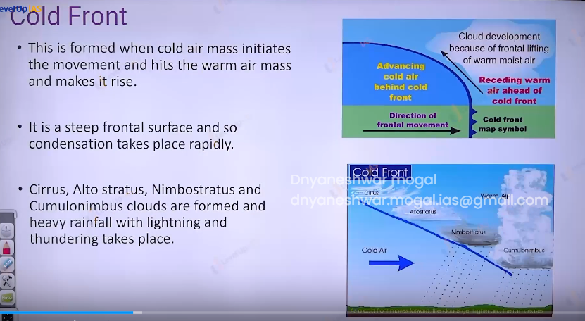e

Cold front

1. This is formed when the cold air mass is active, and it moved into the territory of warm air mass
2. It is steep front and therefore the air raise swiftly passed and the condensation take place rapidly with heavy rainfall of short duration
3. Cirrus, alto stratus, nimbostratus and cumulonimbus cloud are formed. It leads to heavy rain fall with lightning and thunder taking place.

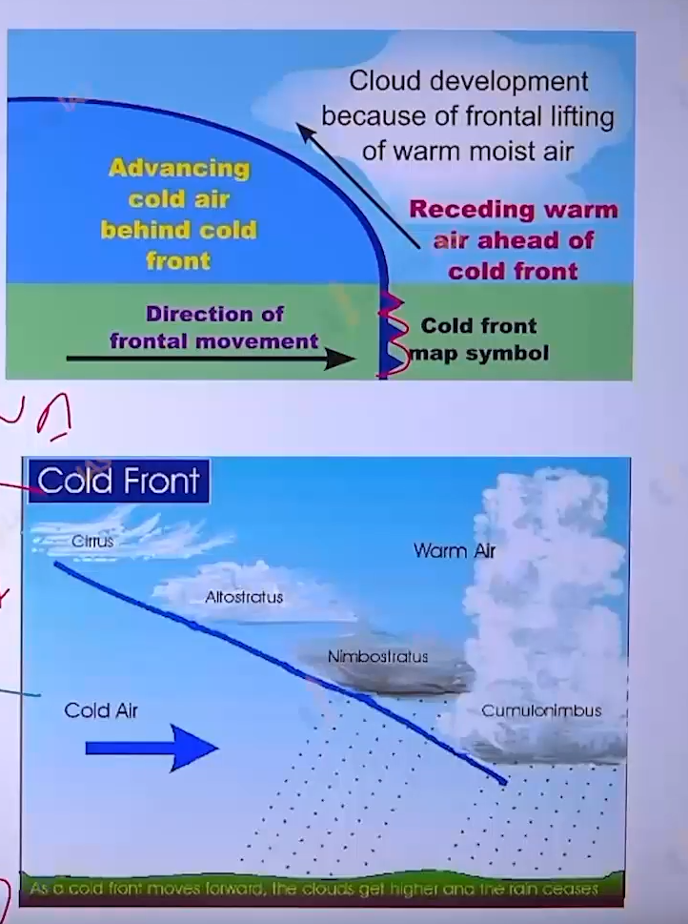

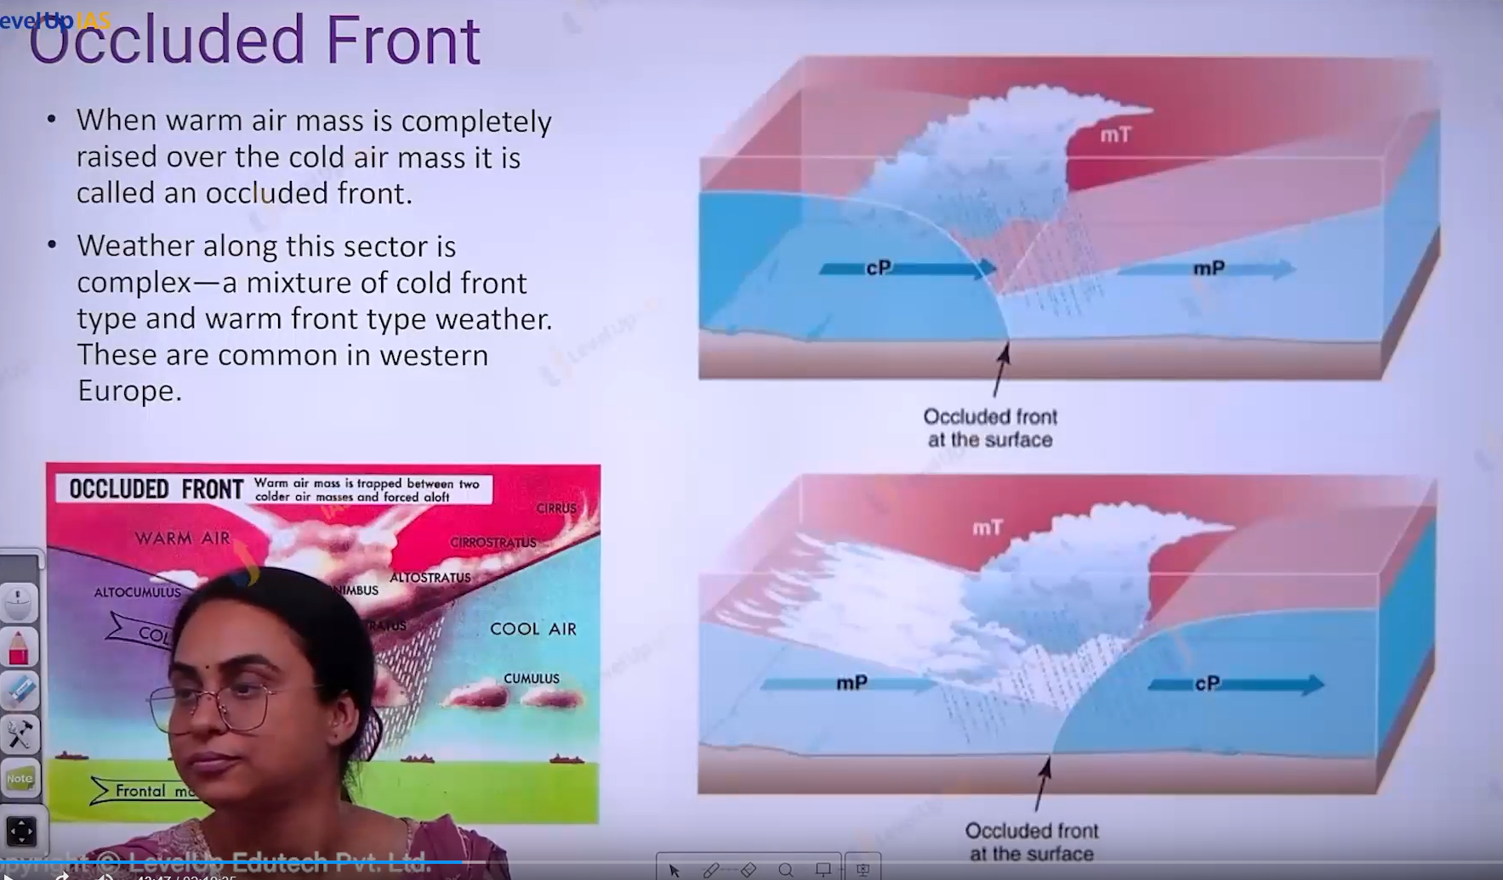

Occluded Front :

1. Warm air complete tossed above the cold air mass
2. Weather along this front is very complex as there is mixture of cold front and warm front.

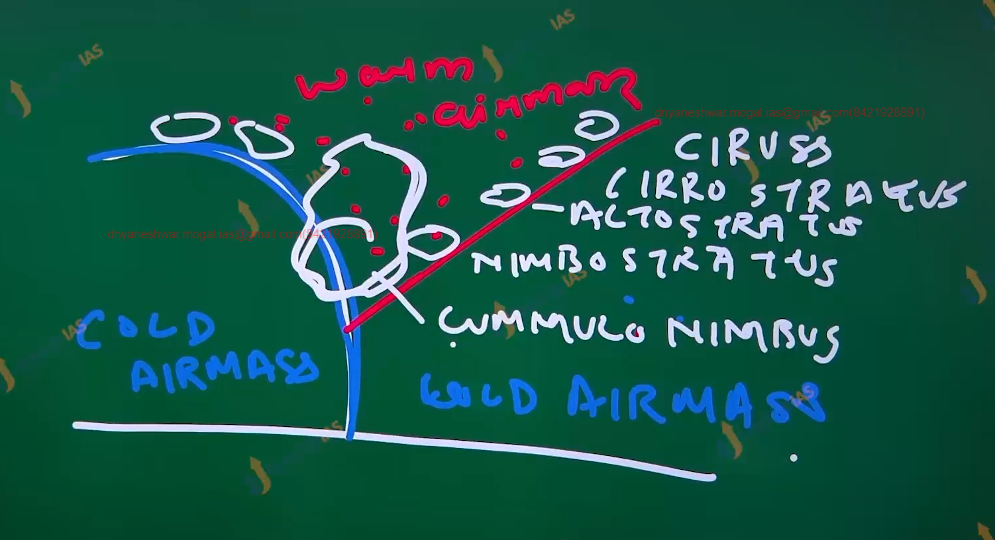

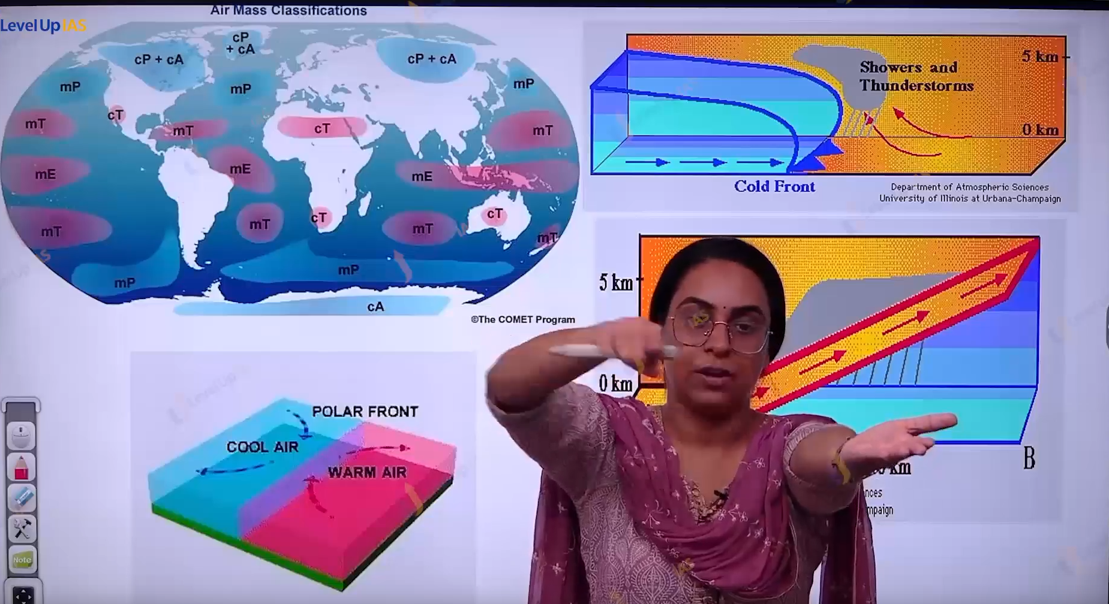.

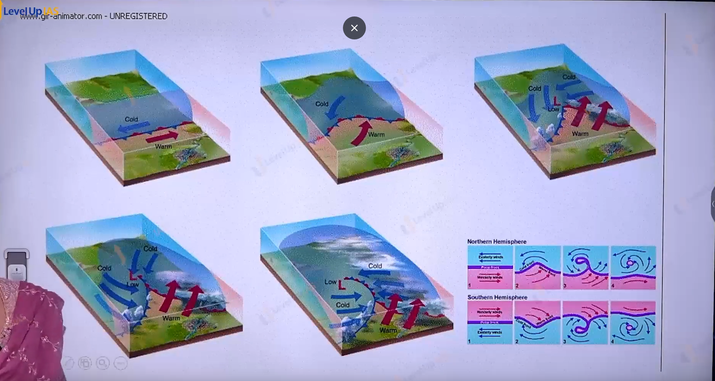

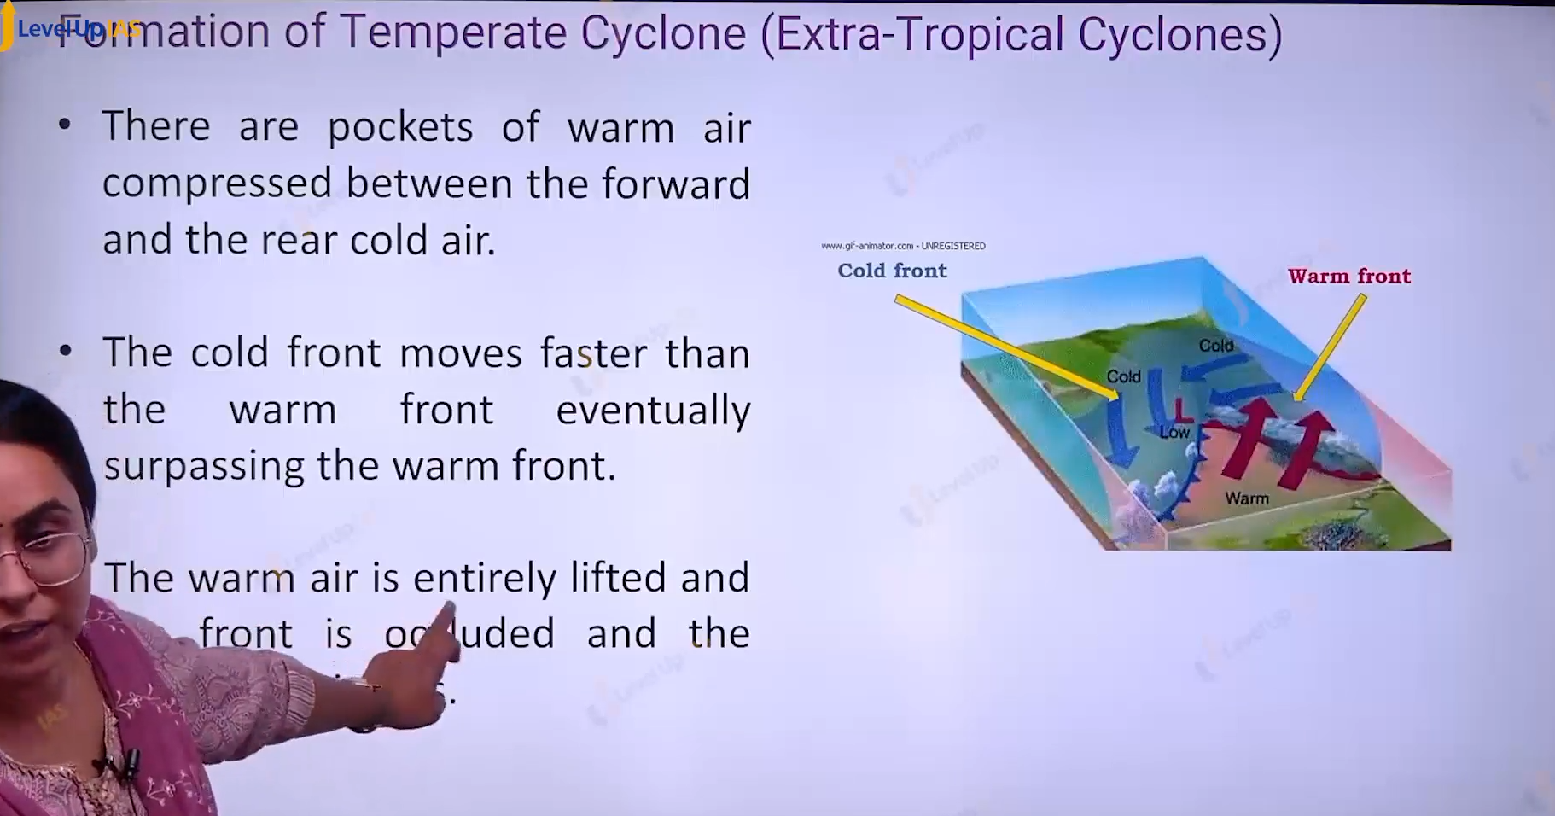

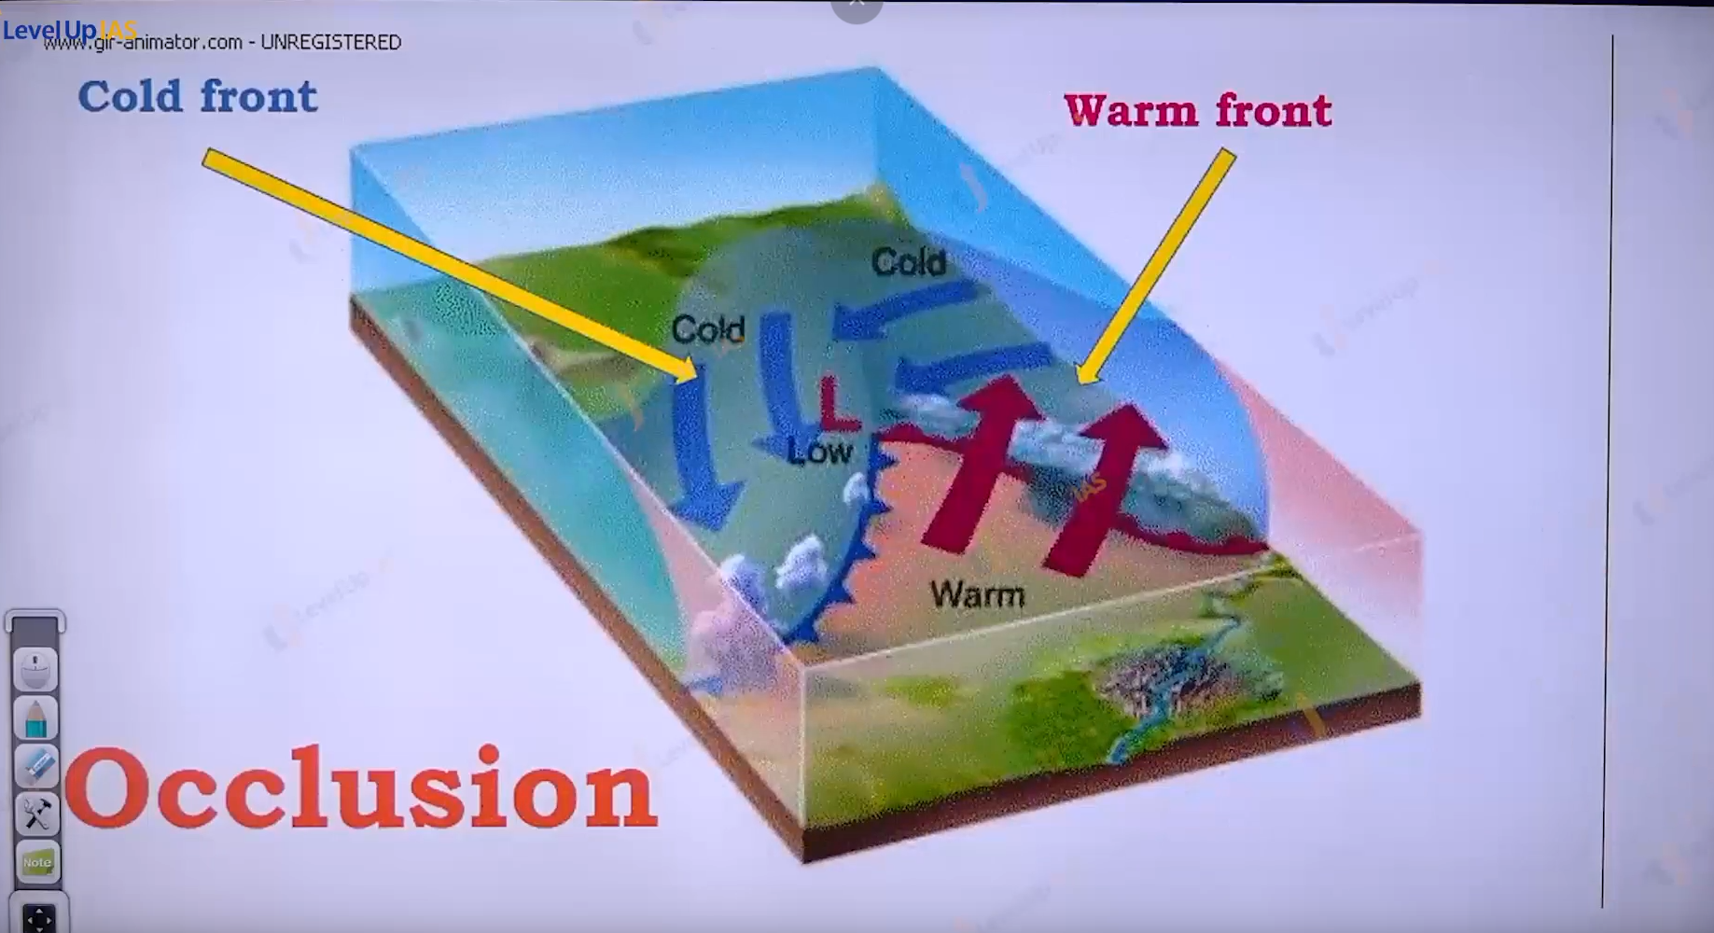

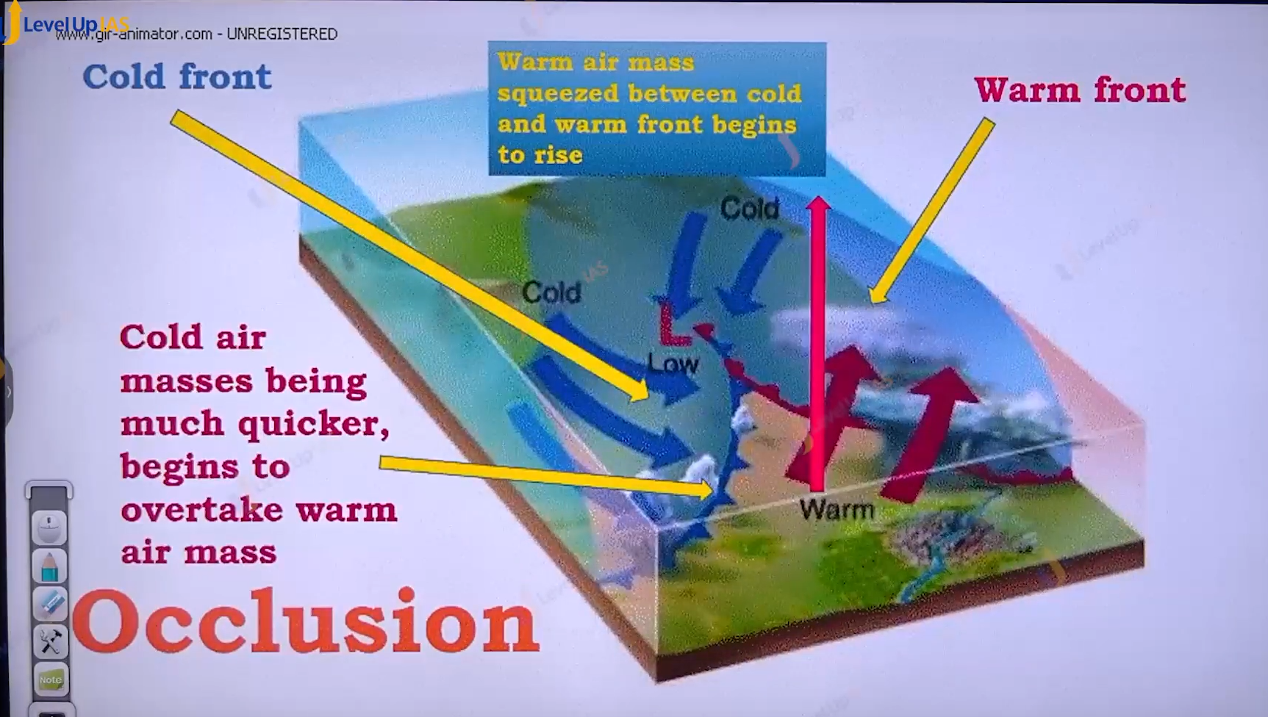

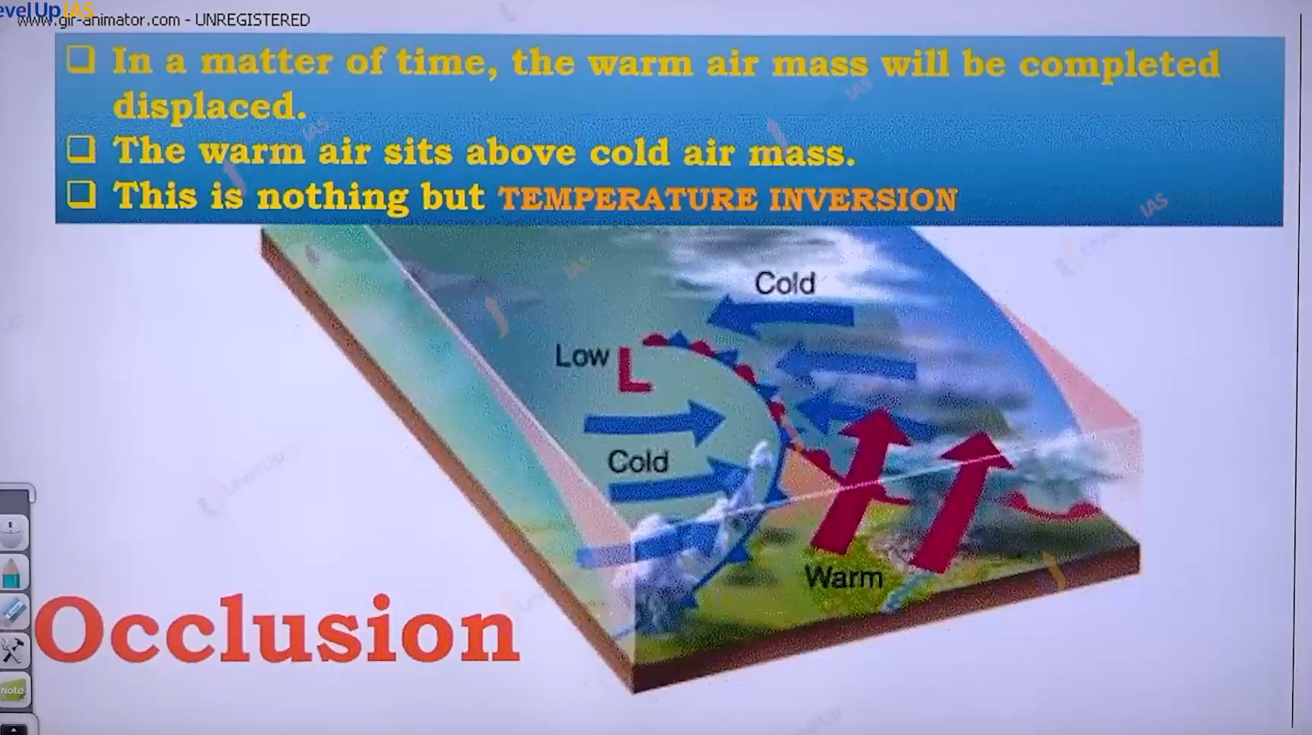

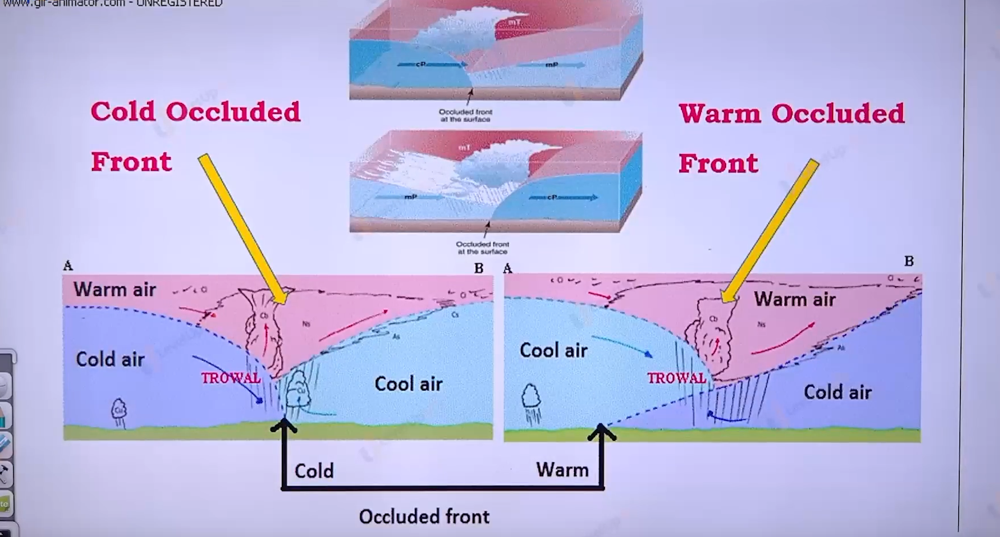

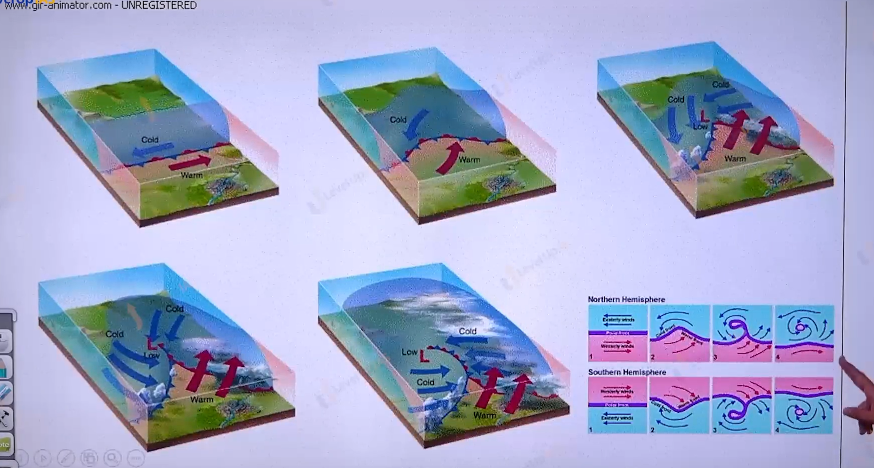

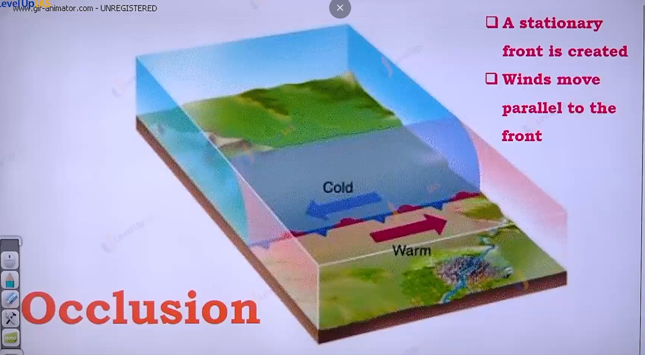

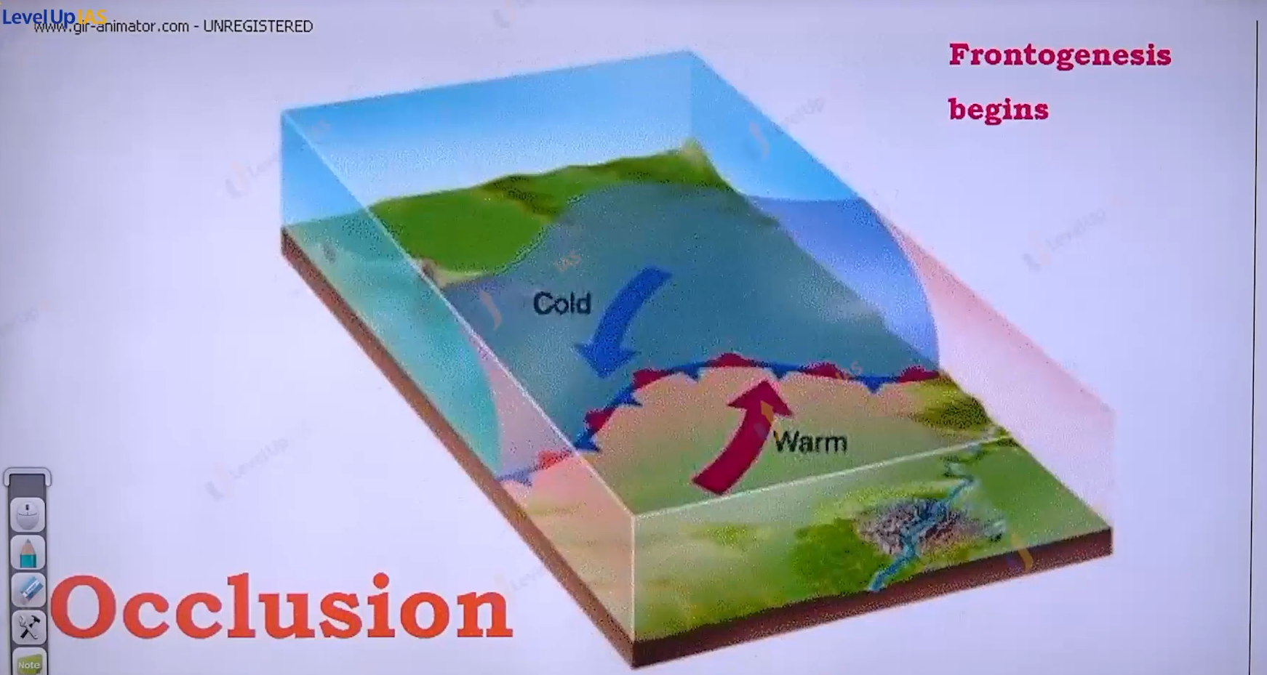

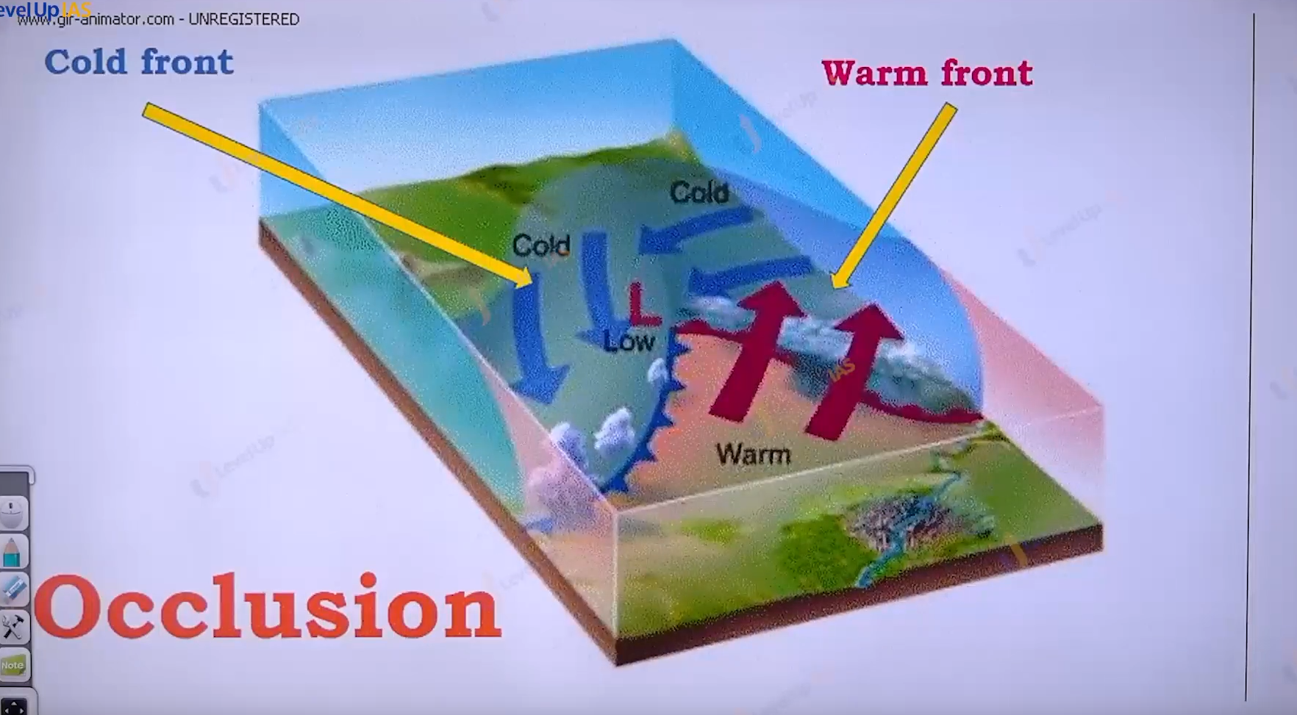

Two front formed, cold is faster therefore the it will reached at the warm front.

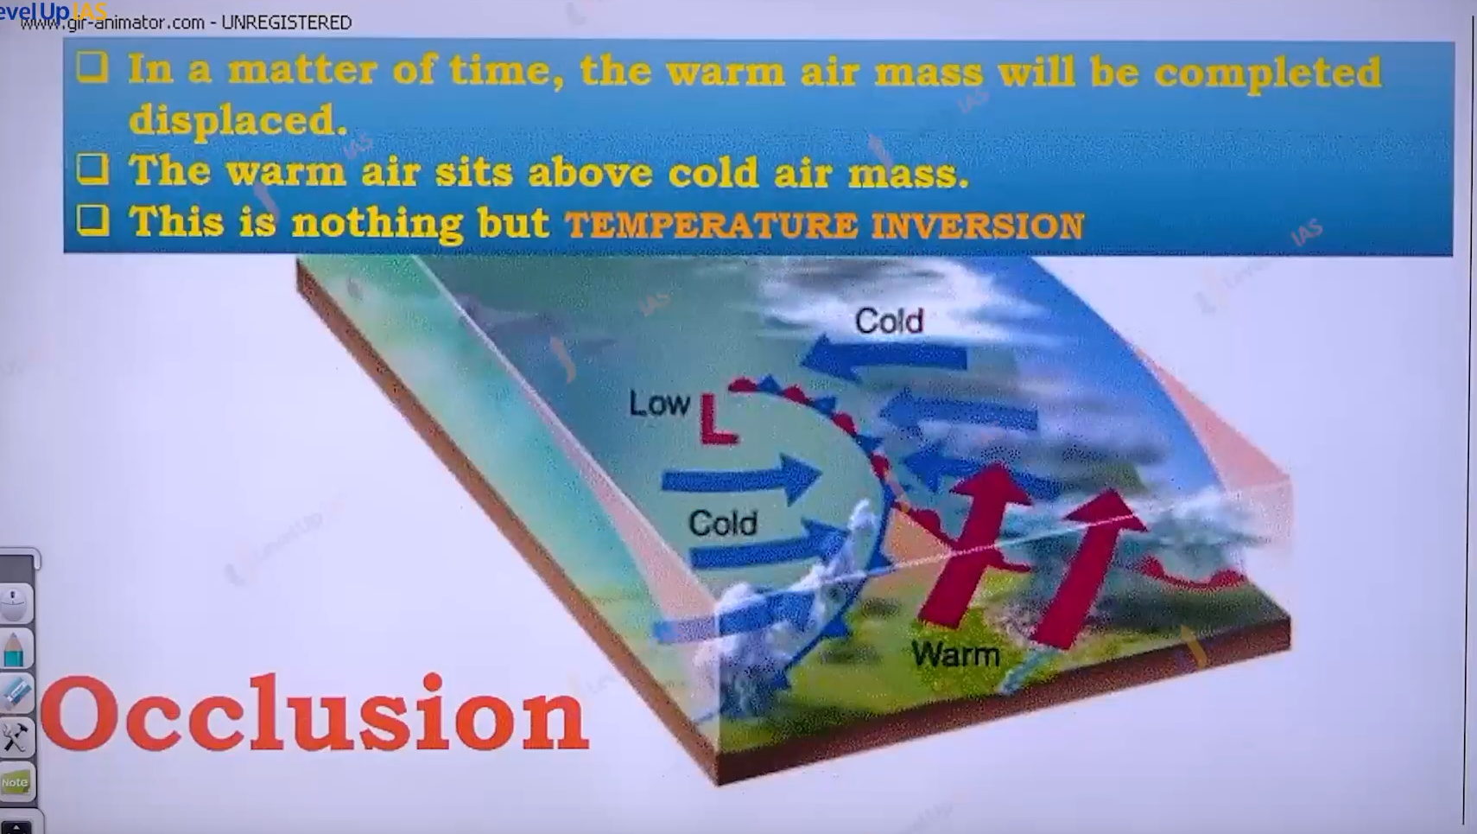

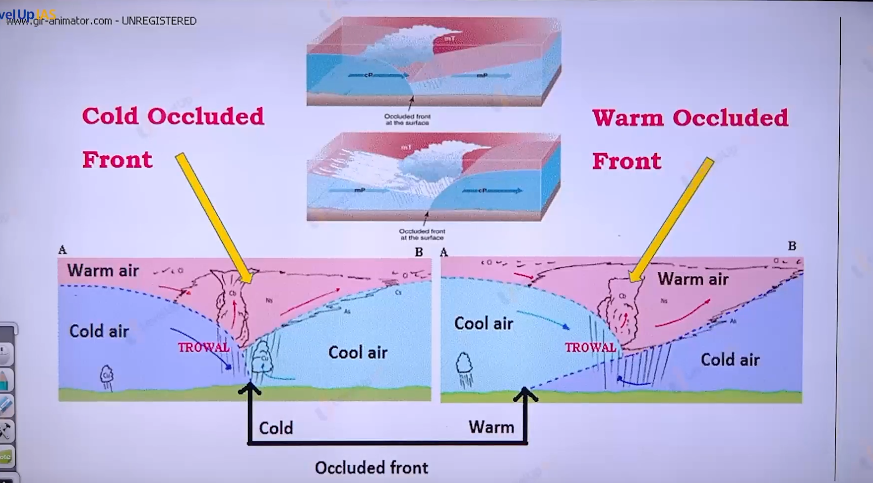

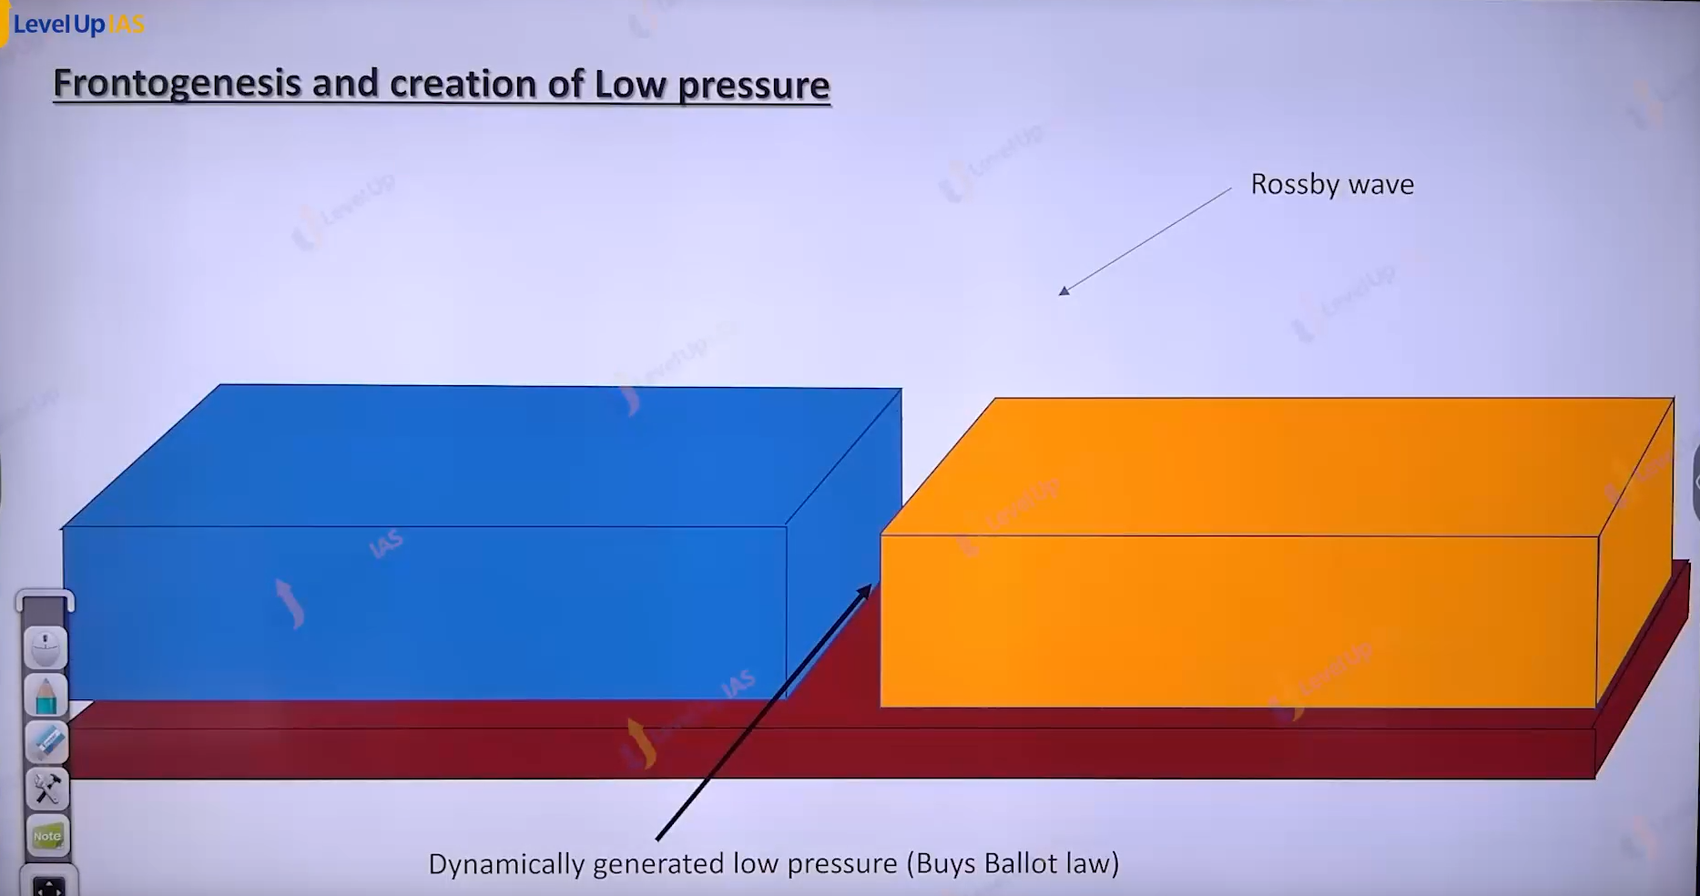

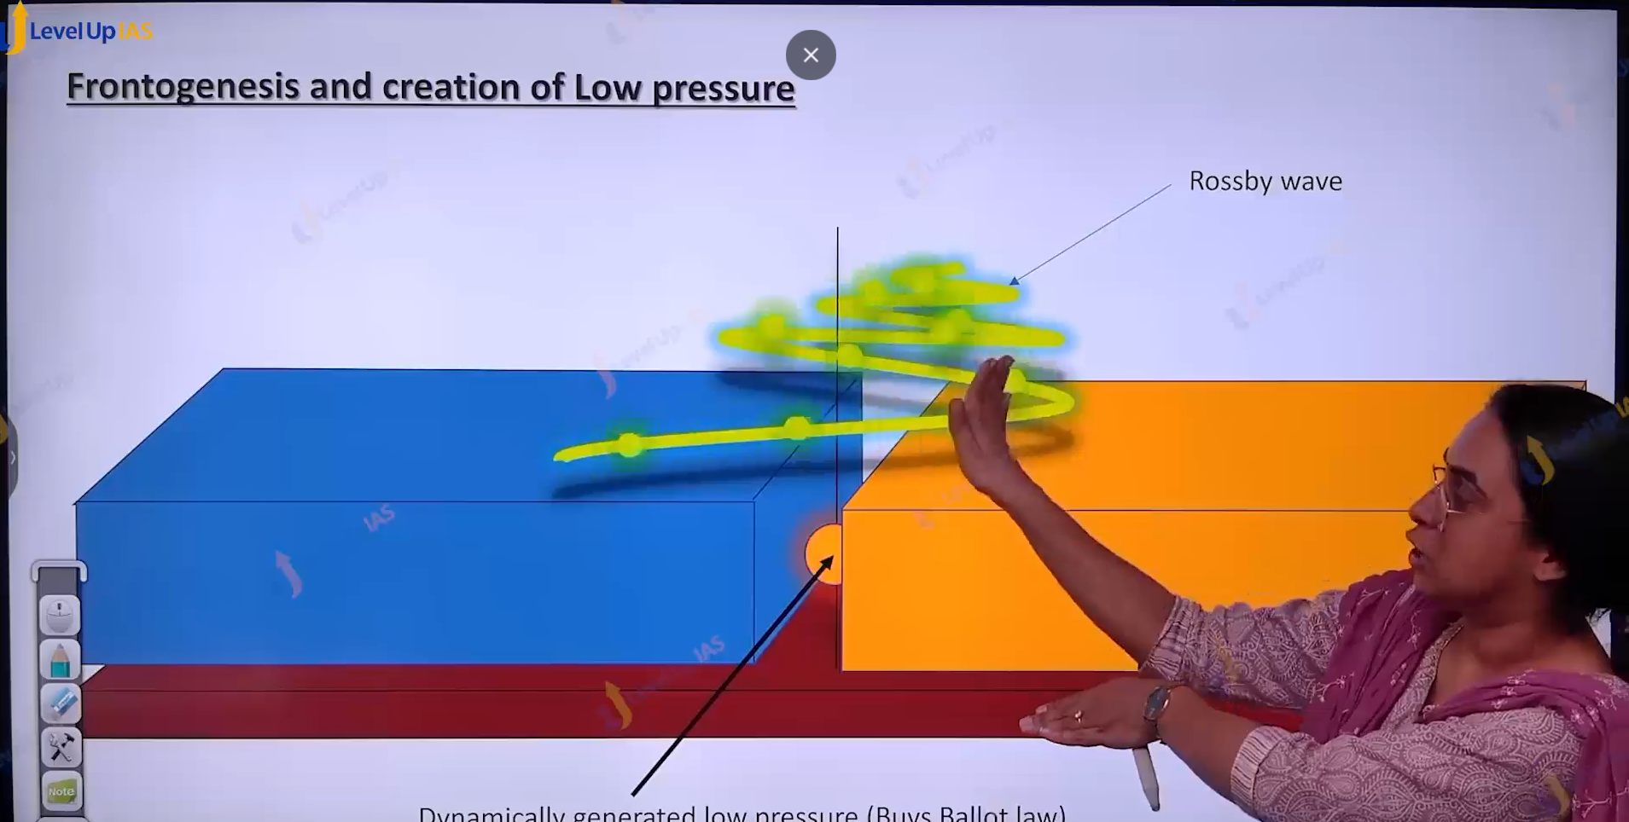

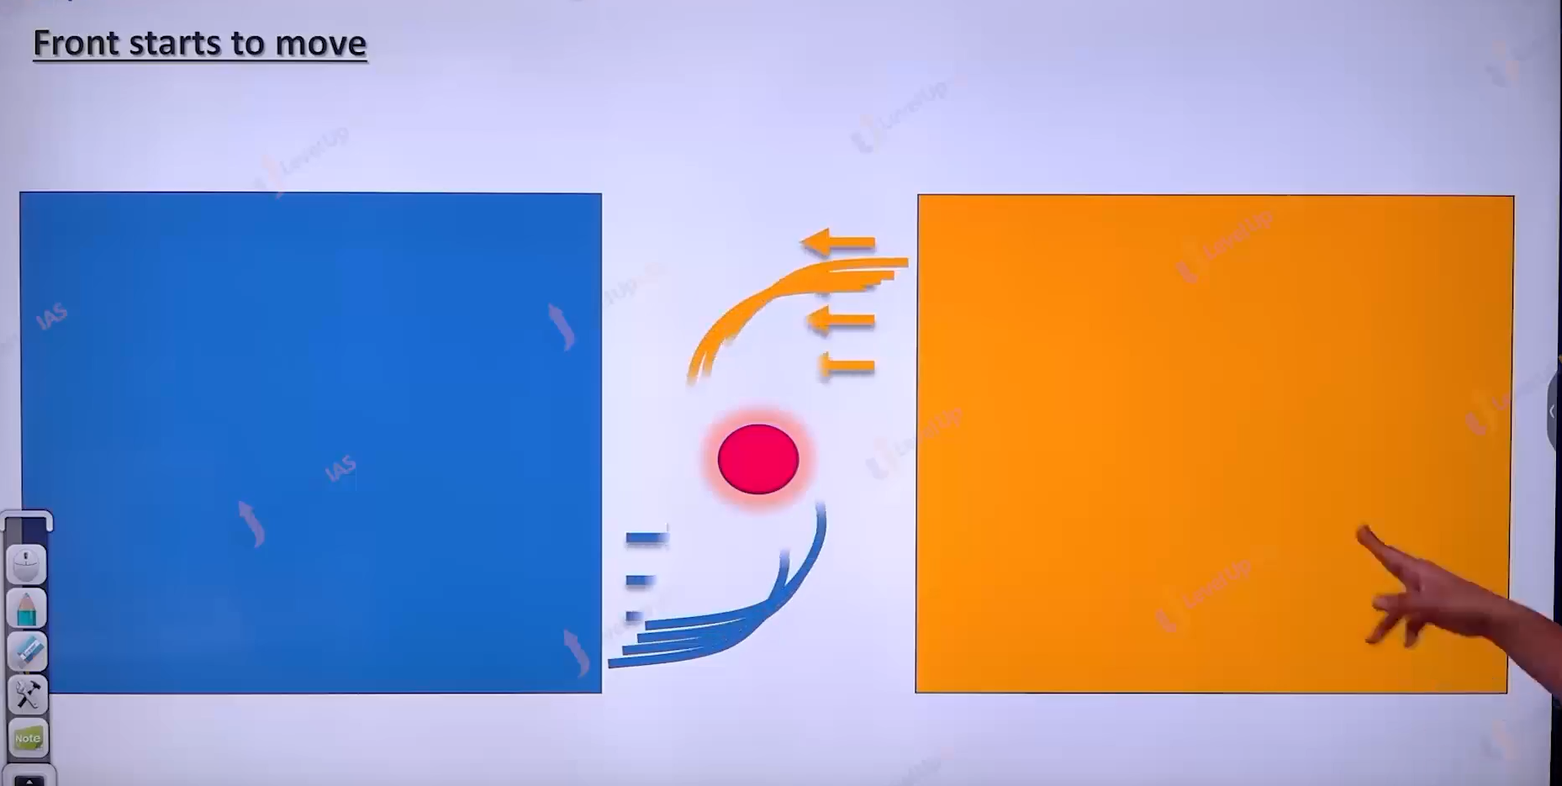

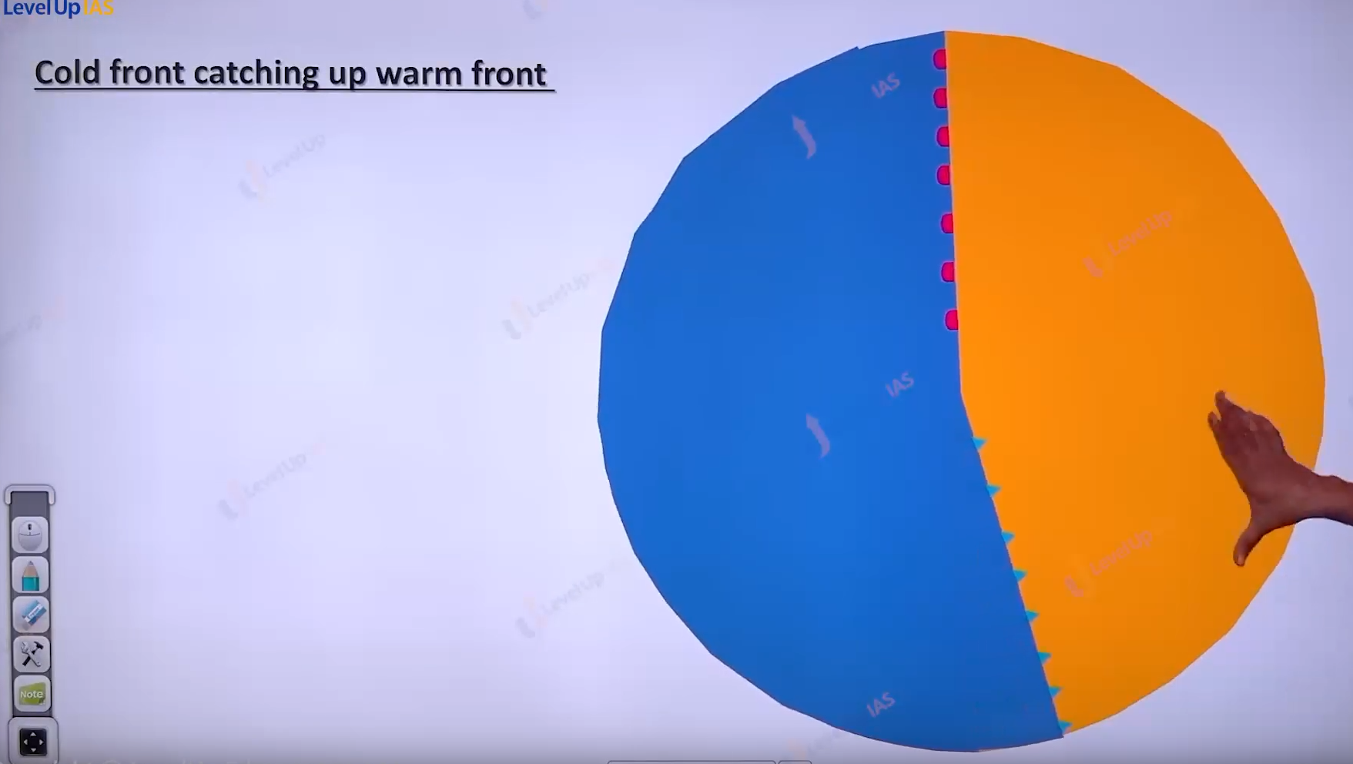

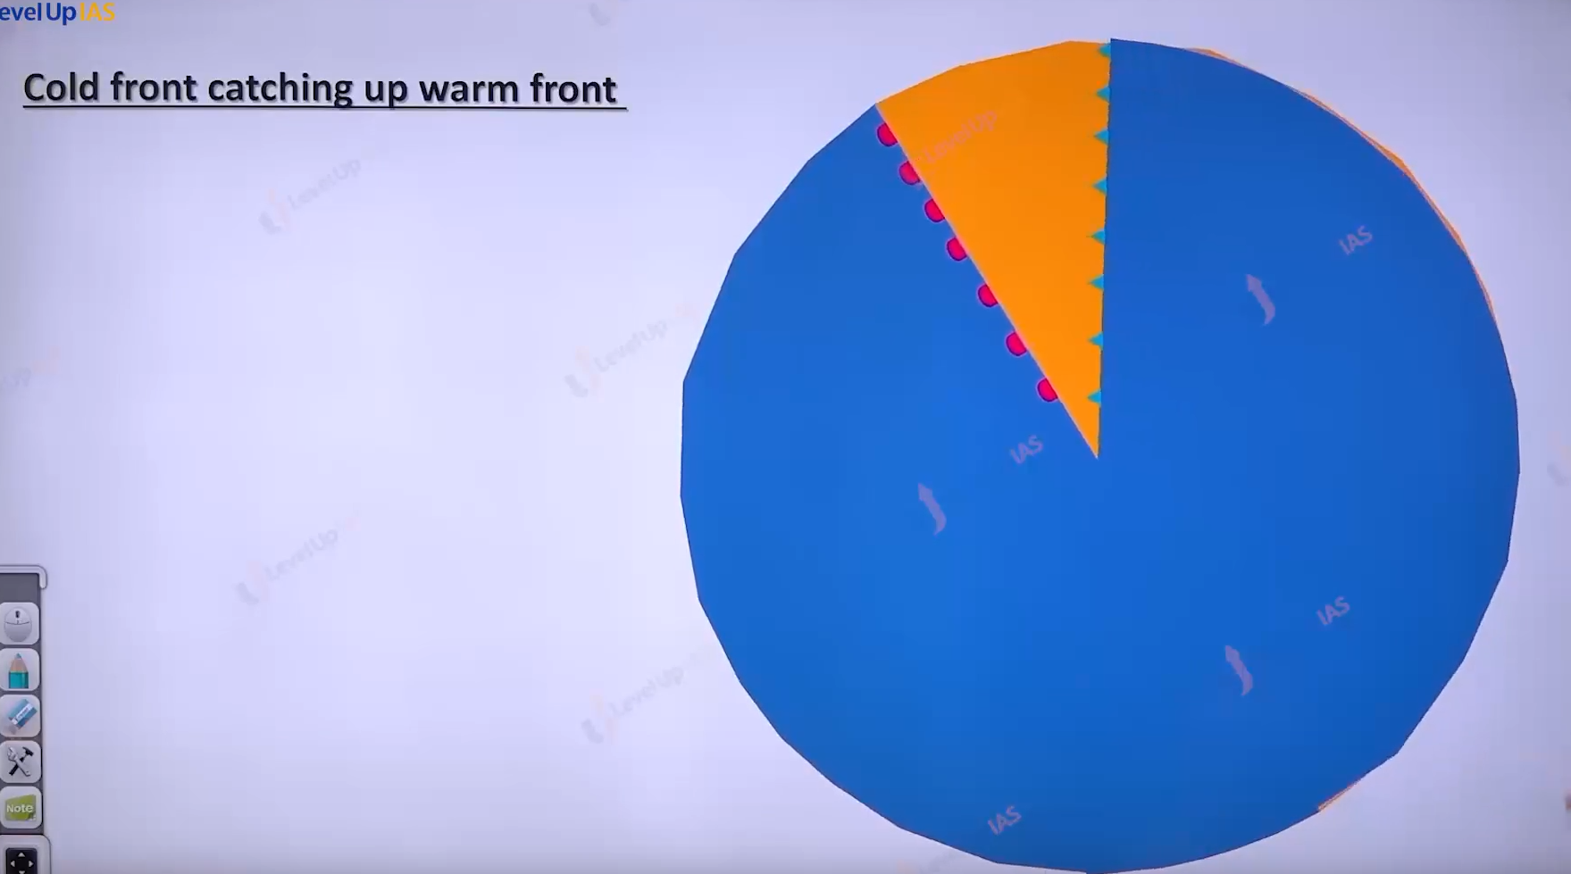

Here yellow is warm air mass and blue is cold air mass . cold air mass is faster it will catch up to warm air mass.

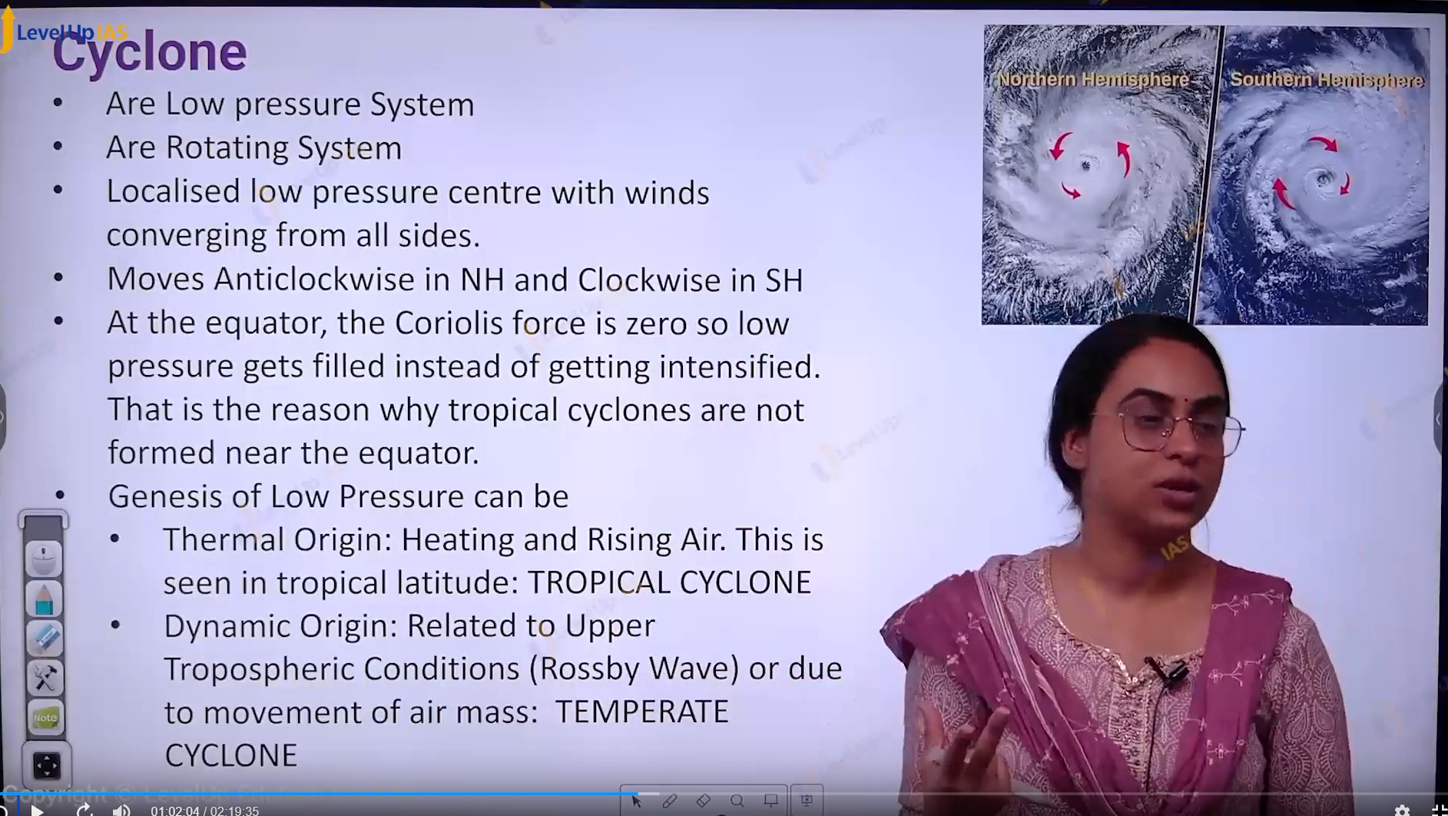

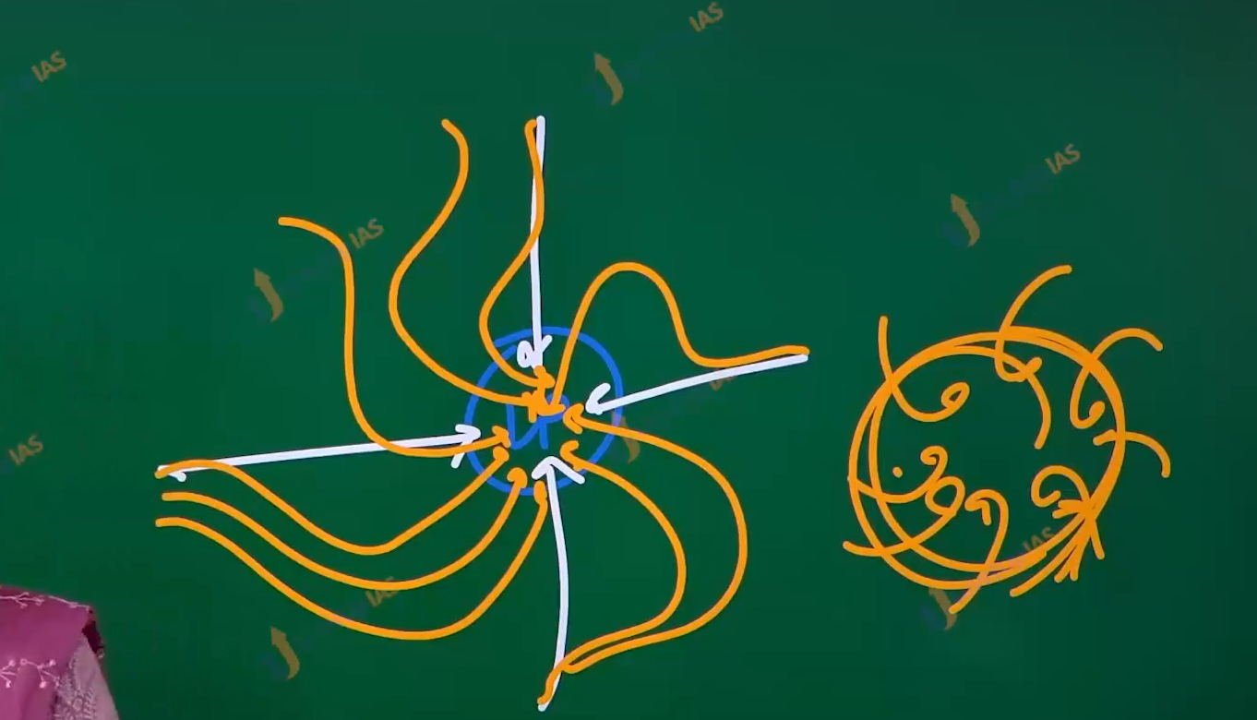

( this is dirgram of cyclone in the northern hemisphere)

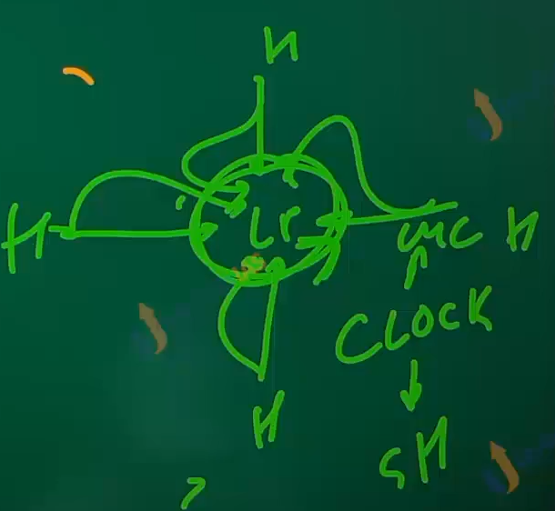

This cyclone in the southern hemisphere.

Cyclone:

1. Cyclones are low pressure systems and
2. They are rotating systems.
3. Where in cyclone localized low pressure exits with winds conversing from the all the site.
4. They moved anticlockwise in the northern hemisphere (ican- cyclone-anti-clockwise in northern hemisphere).
5. At equator the Coriolis force is zero therefore the low pressure is filled instead of getting intensified. This is the reason cyclones do not form at the equator.
6. The genesis of low pressure can be due to
   1. thermal nature heating and raising of air this is seen in the tropical latitude. (Tropical cyclone.) they are warm core cyclone
   2. dynamic origin – related to the upper tropospheric winds.
   3. That is Rossby wave. Also related to the movement of air mass- seen in the temperate cyclone. They are Cold core cyclone.

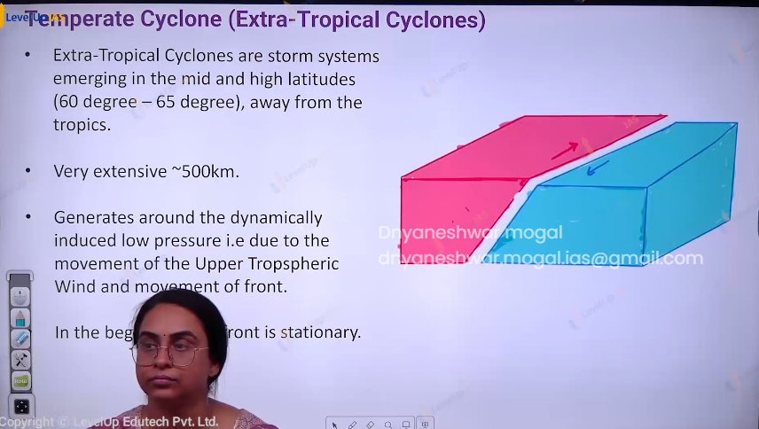

Temperate Cyclone ( Extra-tropical cyclones )

1. They are storm system emerging in the middle latitudes 60 – 65 degree latitudes.
2. They are extensive system.
3. The temperate cyclone developed around the dynamic induced low pressure that is due to movement of Rossby wave and duo to movement of fronts.

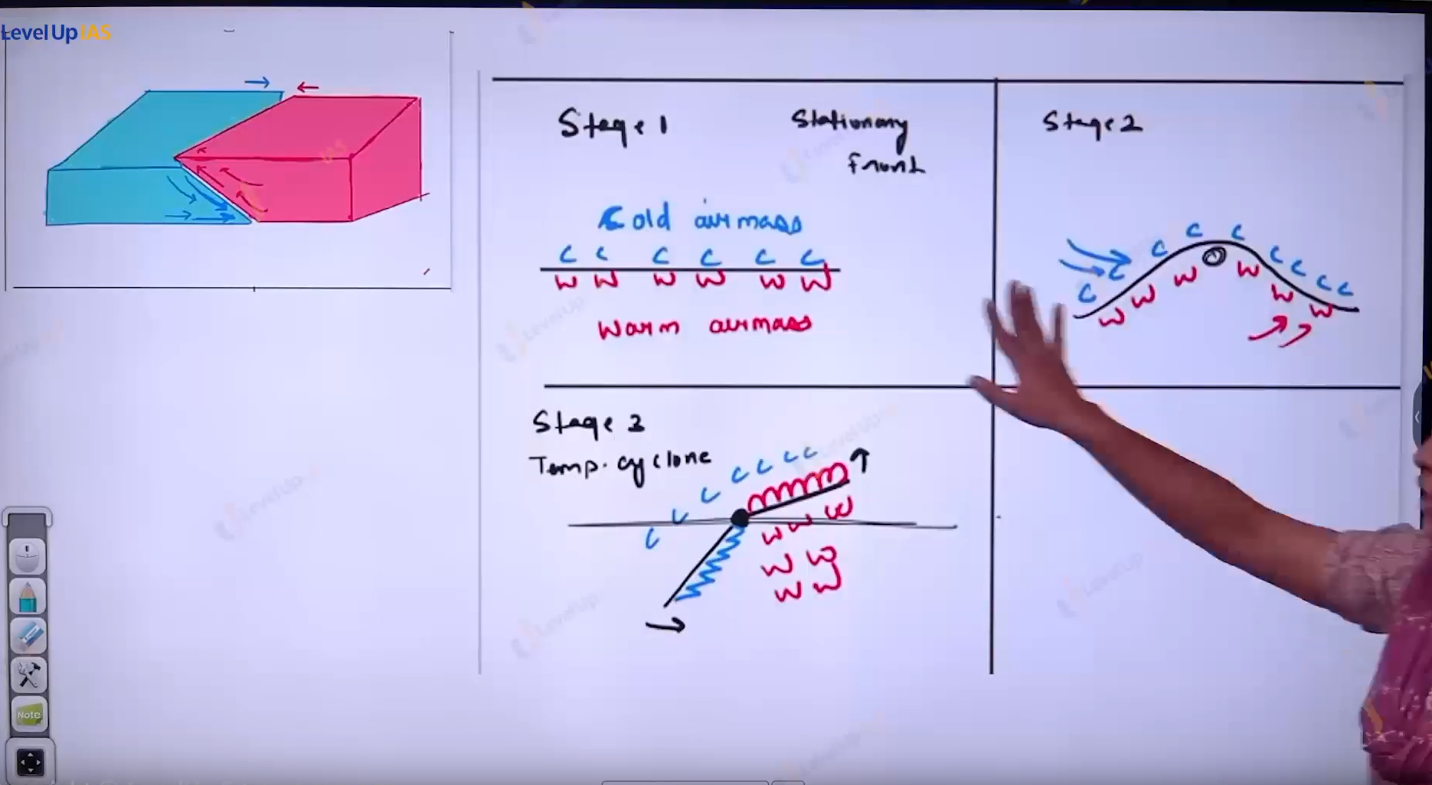

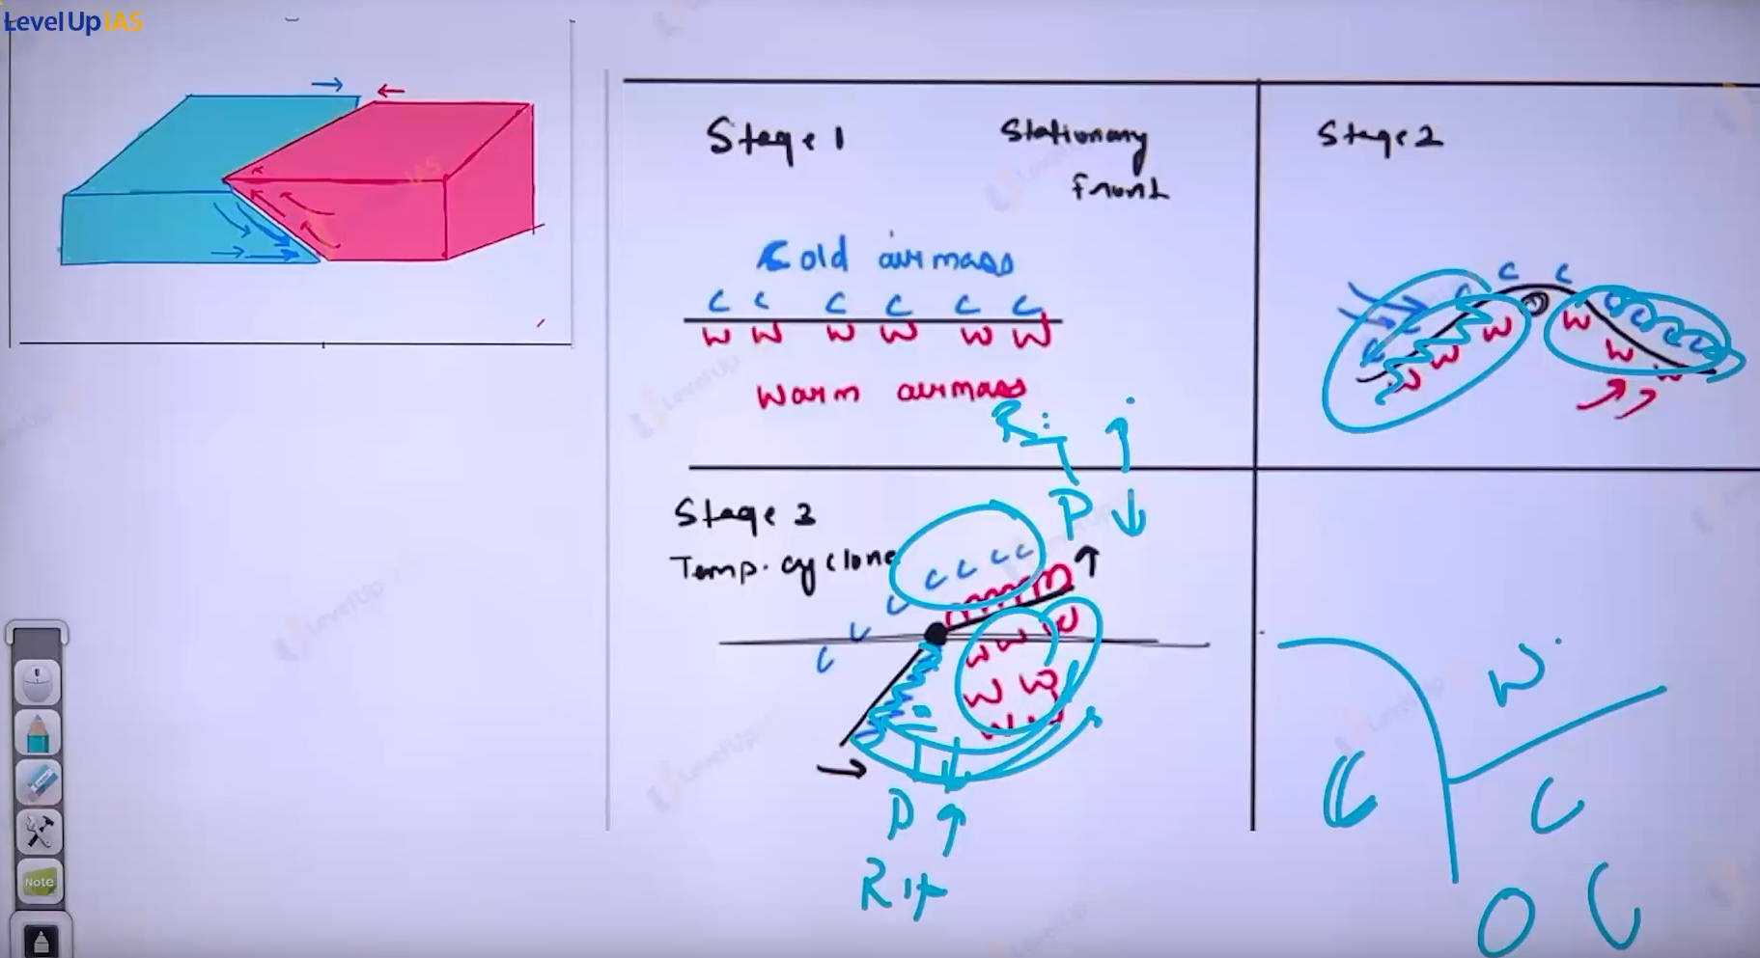

1. In the beginning the front is stationary then low pressure is developed in the northern hemisphere.
2. The cold air mass blows from the north from the front and warms air mass blows from the south.
3. When the pressure falls along the fronts cold air moves towards the south and warm air moves towards the north setting in motion an anti-clockwise circulation.
4. cyclonic circulation developed into temperate cyclone cold front and warm front.
5. There are pockets of warm air compressed between the forward and rear cold air
6. Cold front moves faster than the warm front, eventually surpassing the warm front.
7. The entire warm air is entirely lifted and the front is occluded this marks end of temperate cyclone.

Features of temperate cyclones:

1. They are a massive system which extends 1000 km with the radius exceeding 200 to 300 km.
2. It is more intense in the winter because of stronger air mass contrast.
3. Compared to tropical cyclones which are much smaller and stronger system temperate cyclones are not as violent.
4. The winds velocity is 50 km/hour 80 km/h.
5. If temperate cyclones move from the west to east under the influence of westerlies.
6. Temperate cyclones can be developed both land and ocean unlike tropical cyclones that can formed only on the warm water and never on the land.
7. In the mid latitudes the favorable location for then temperate cyclone permanent low-pressure cell in the sub polar region ex loosen low pressure cell, islanding low pressure cell. And also, along the Mediterranean low-pressure cell.

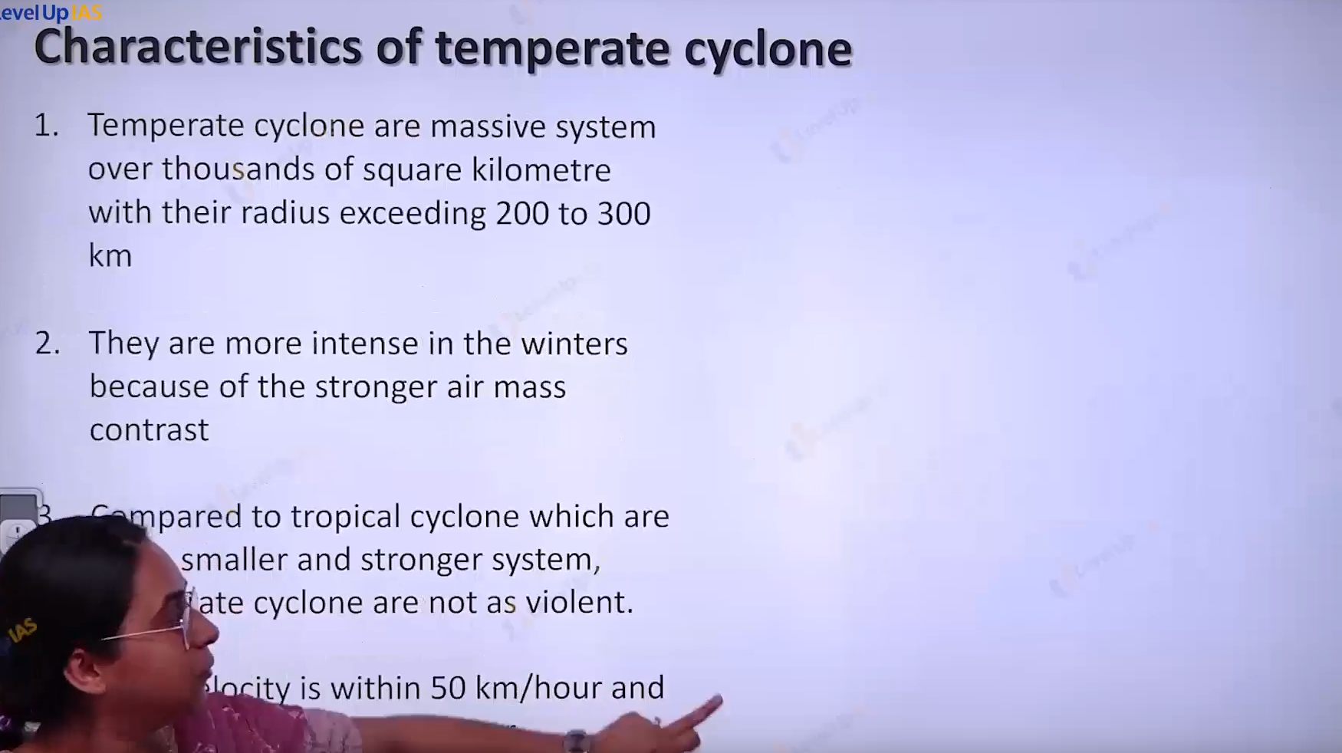

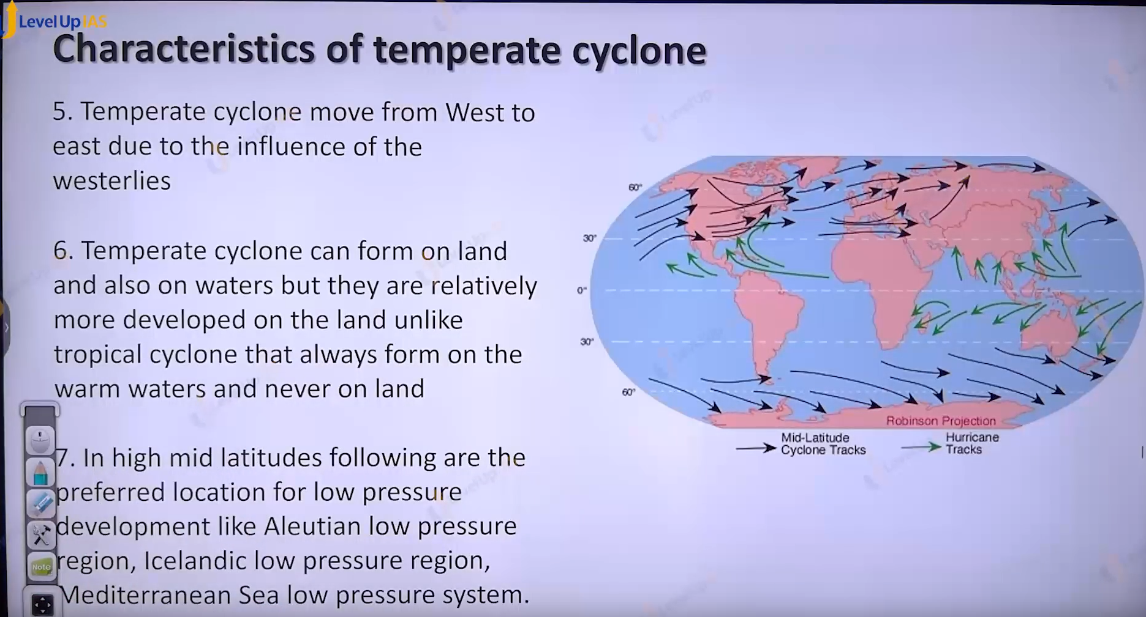

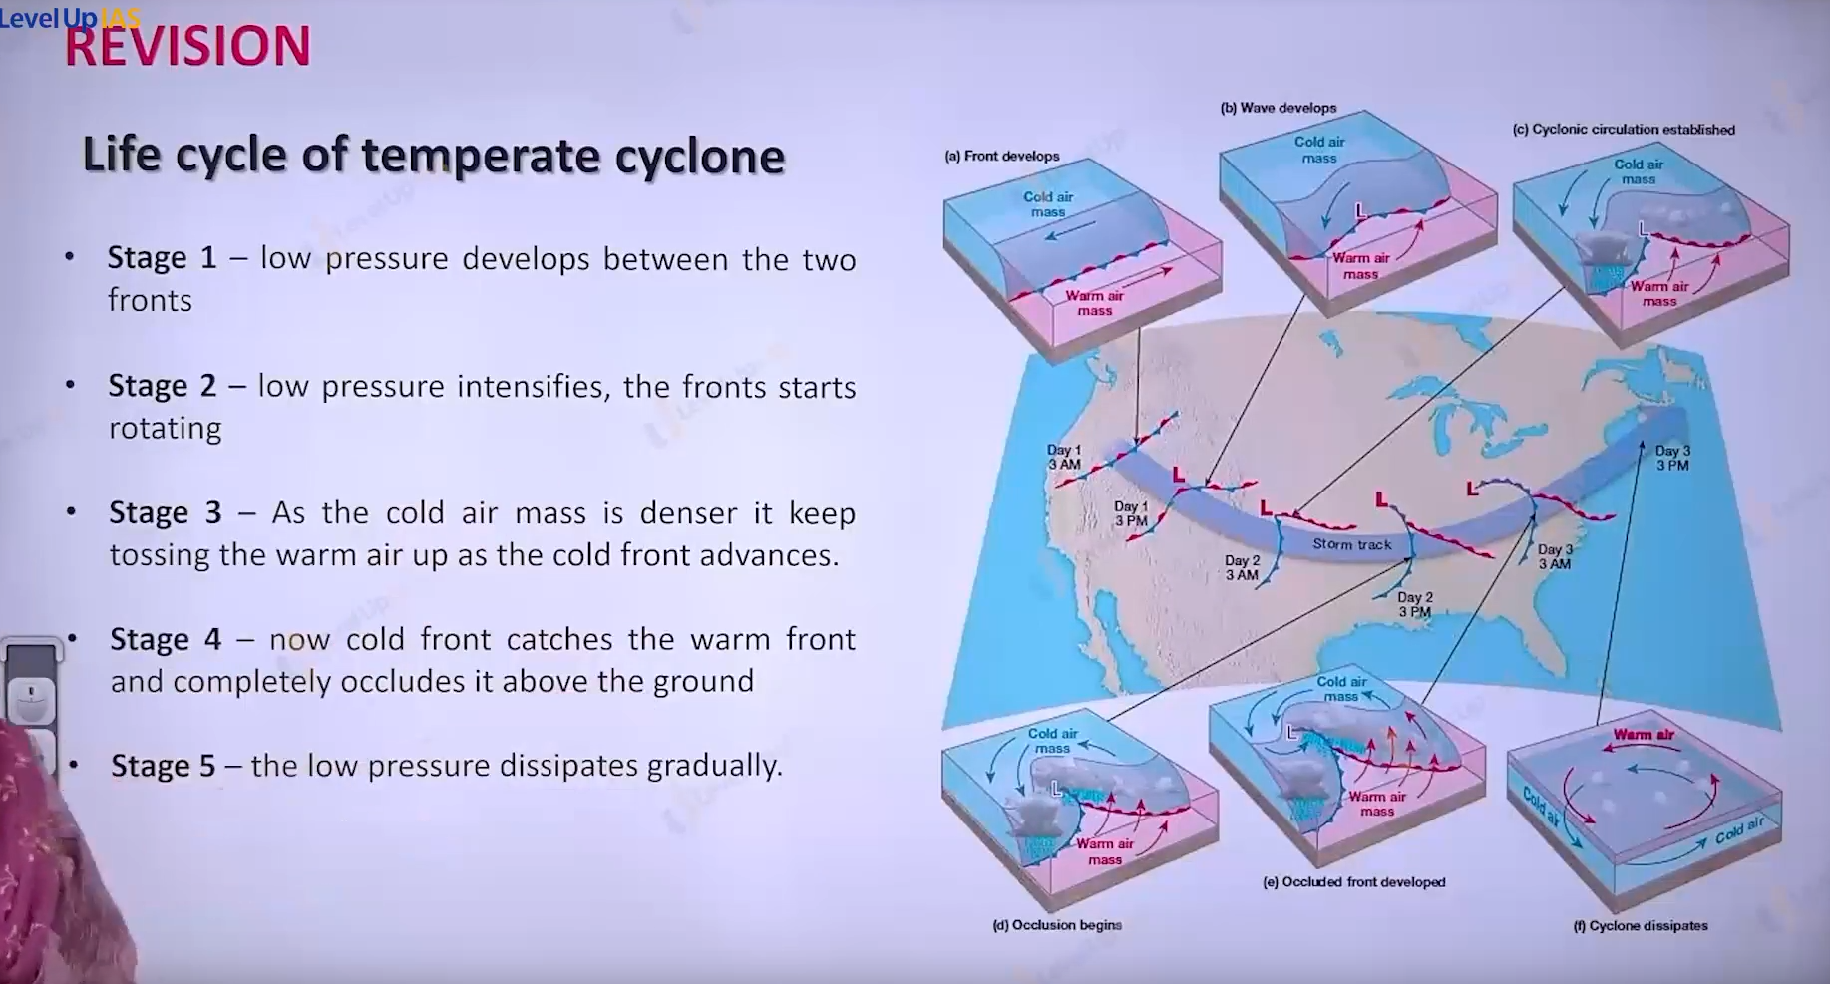

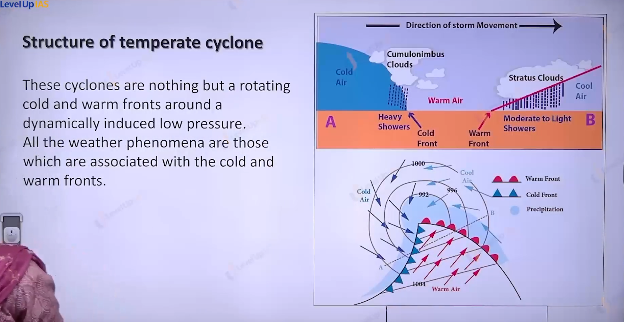

Structure of temperate cyclone:

1. Temperate cyclones are nothing but the rotating system of cold front and warm front around the dynamically induced low pressure.
2. All the weather phenomena which are associated with the cold and warm front are experienced in the temperate cyclone.

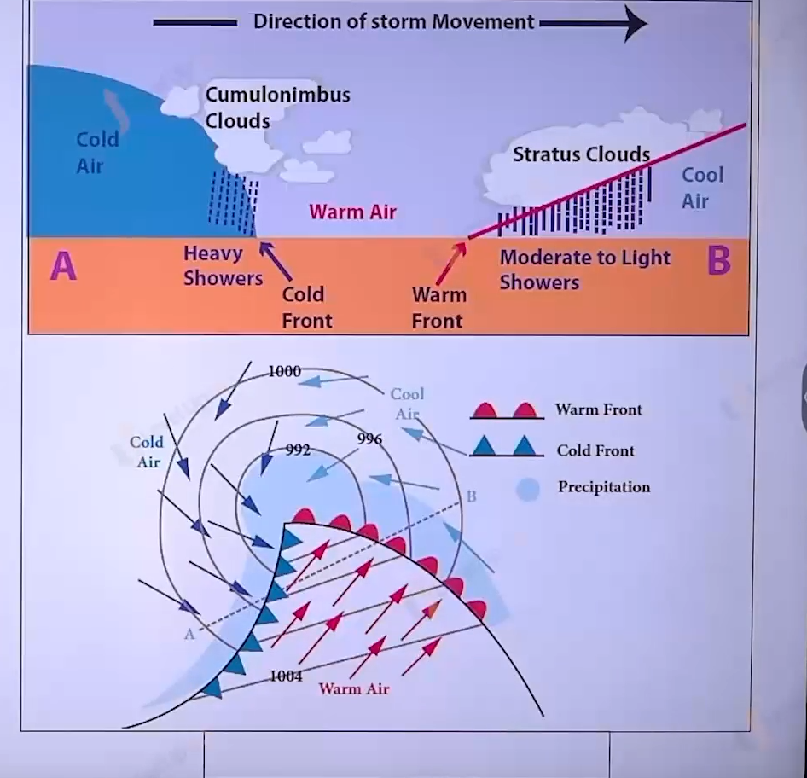

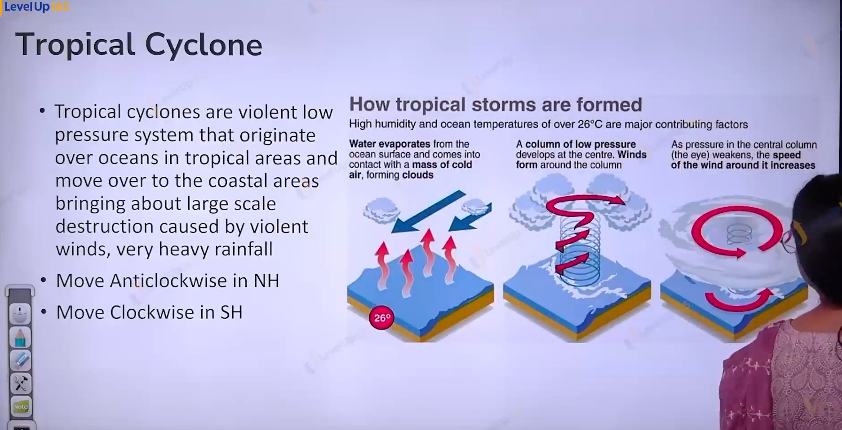

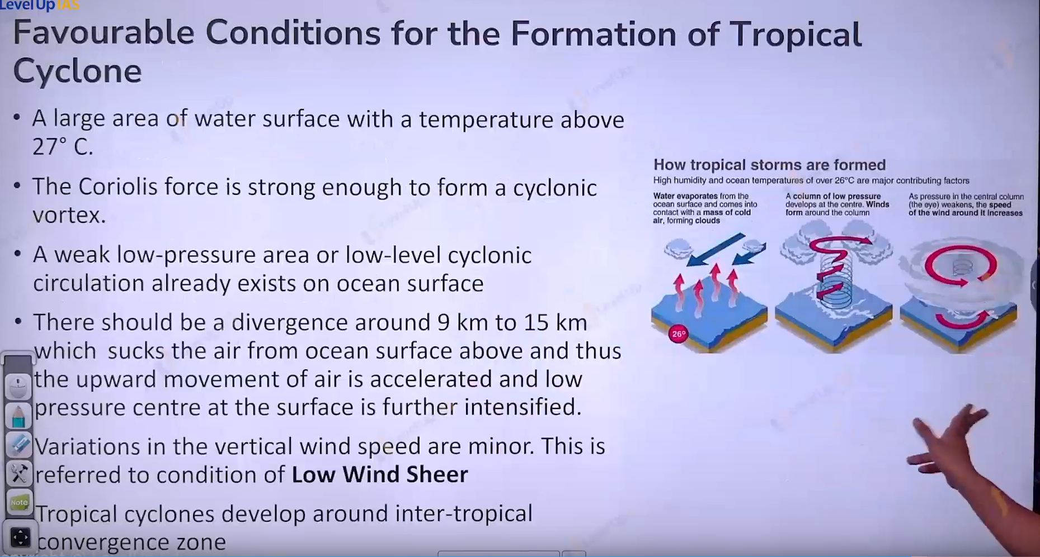

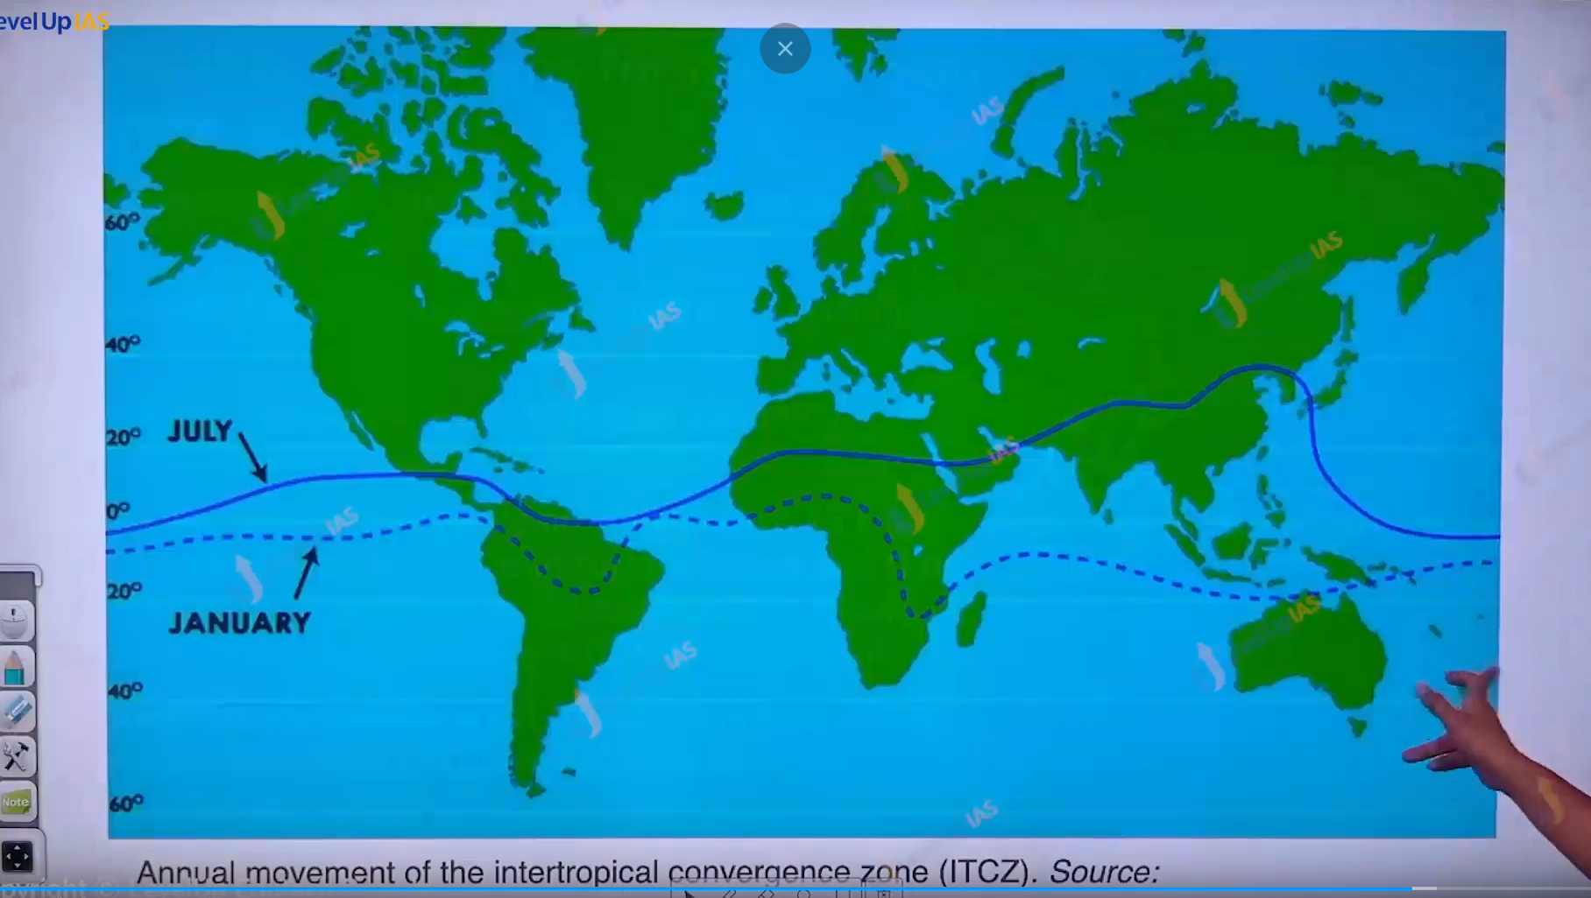

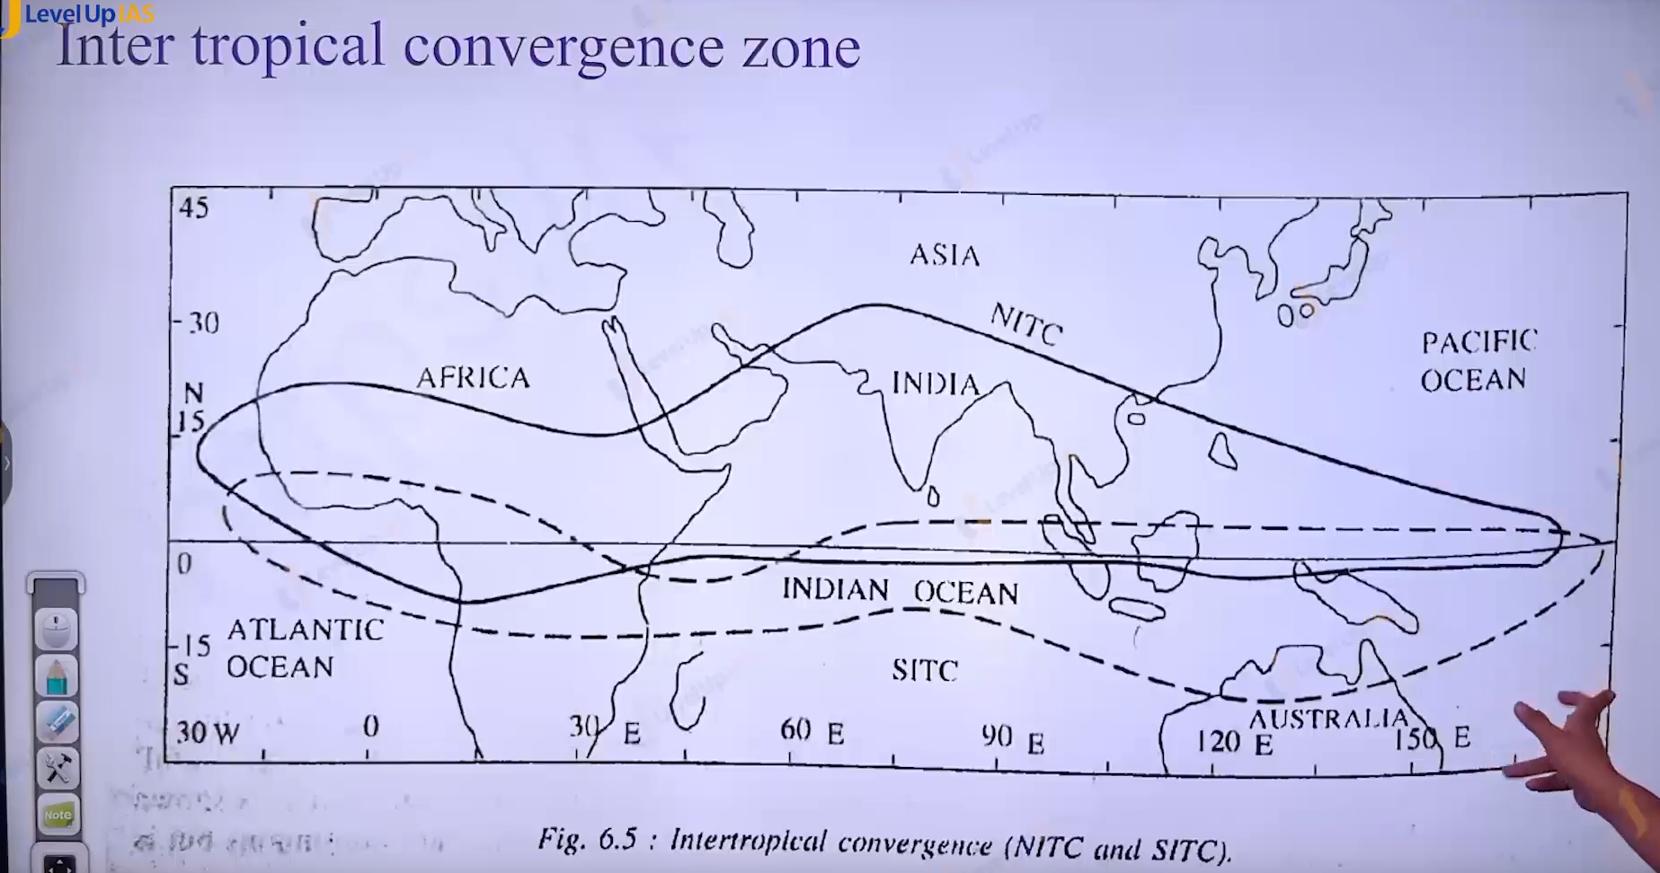

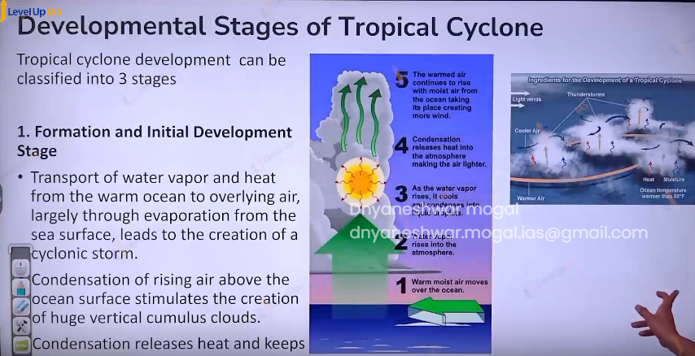

Tropical Cyclone:

1. Tropical cyclone are violent low pressure system that originates over the ocean in the tropical area. and moved to costal area and bring about large scale distribution due to volent ring and very heavy rain fall it move anti clockwise in northern hemisphere and clockwise in southern hemisphere.

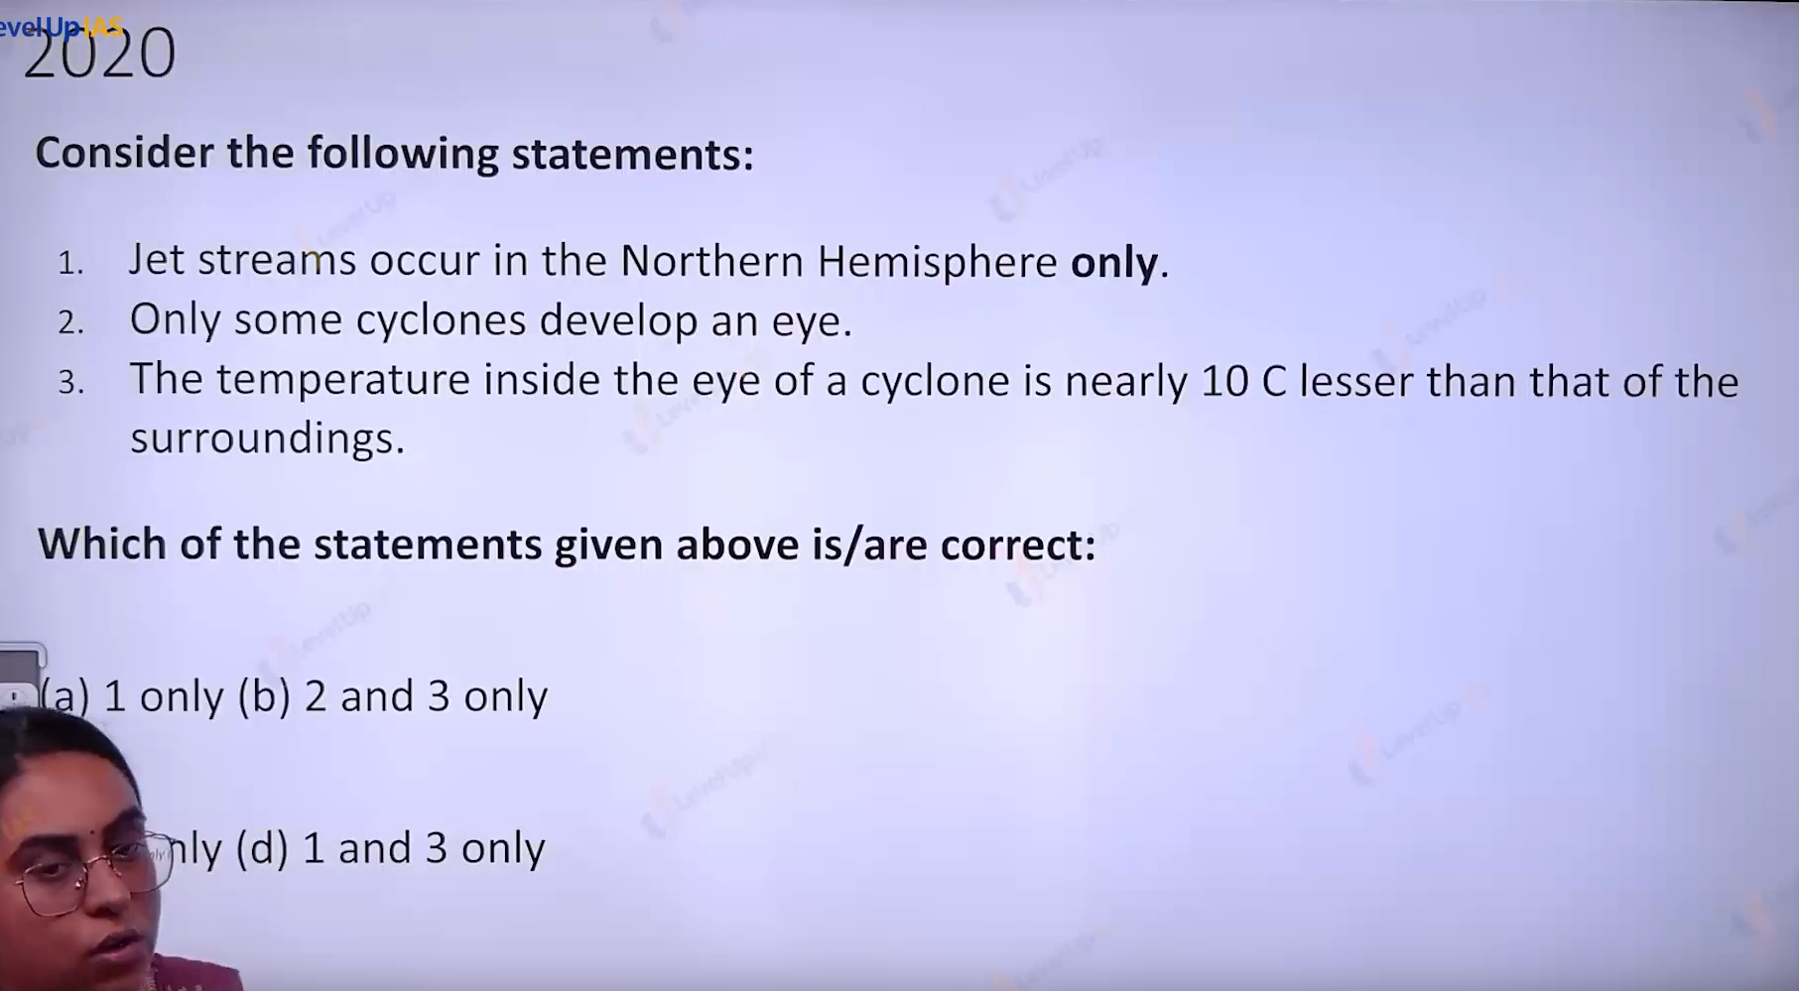

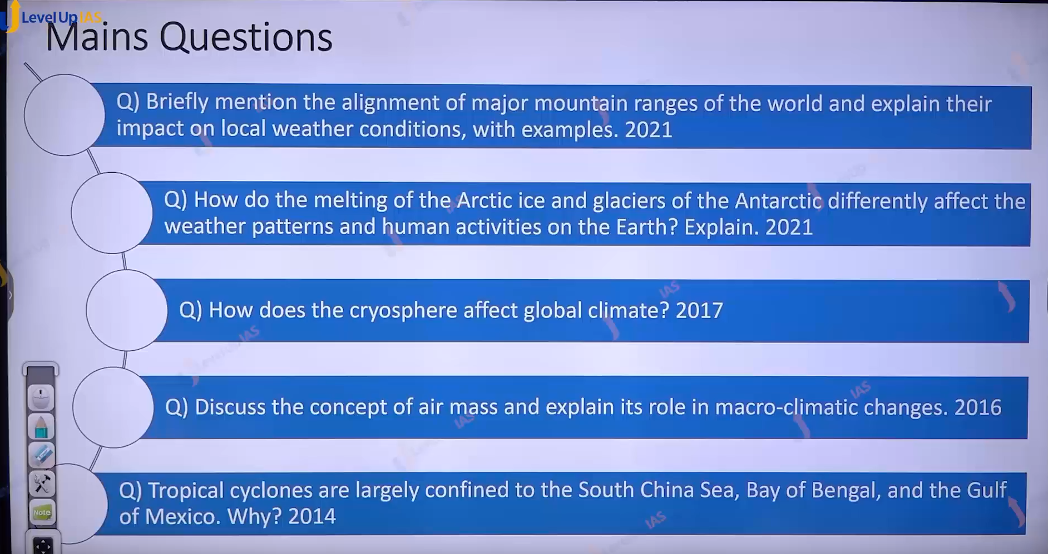

1. Major mountain ranges Himalia , Andes Rockies alps Urals , great dividing range darkening berk.
2. Their impact on the local weather condition
   1. Moisture
   2. g

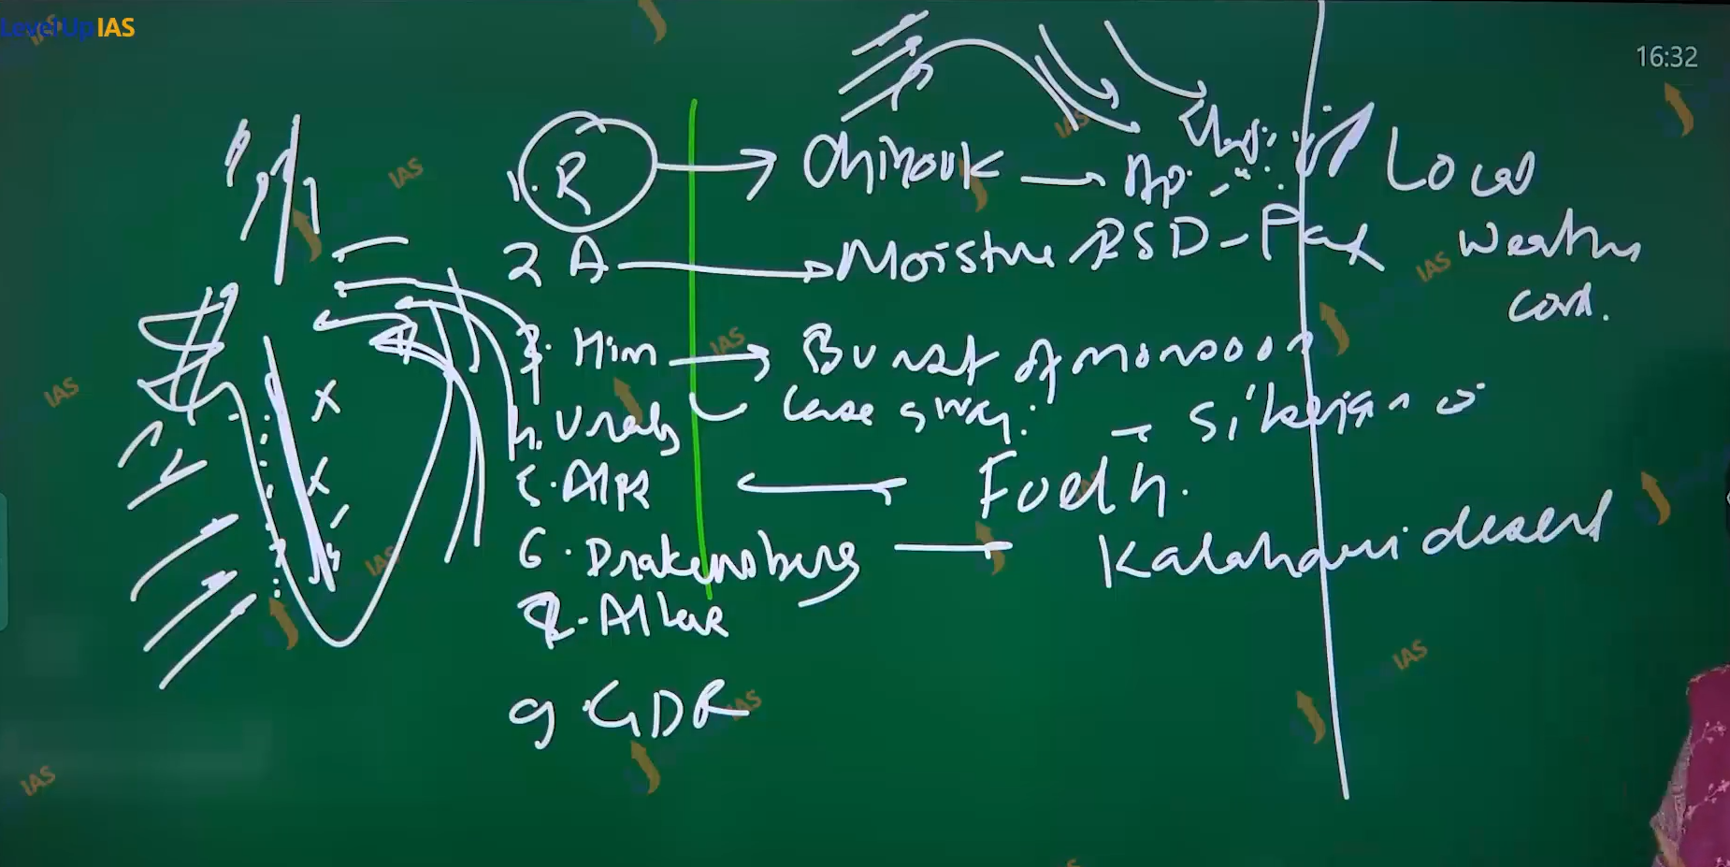

Write the one of effect on climate for each ranges for the



Cryosphere meaning ice

1. Albedo reflecting heat
2. +ve feed back loop
3. Hp stability of pole
4. Stability in the atmosphere.
5. Past climate.